# JAVA

**Important Concept: Order of static blocks in Java**

In Java, **all static blocks run in the order they appear in the code**, **before the main() method is executed**.

🡺Java is ALWAYS Pass by Value.

**🡺**A class can implement **multiple interfaces** but can extend only one class.

🡺**Use the chaining method:** This is a *collision resolution* technique, where each bucket in the hash table points to a linked list of entries that hash to that bucket. It doesn't *prevent* collisions but handles them effectively. This is an **effective technique** for resolution.

🡺exe**Main Thread:** When a Java program starts, the JVM creates a main thread to execute the main method. So, there's always at least one thread.

**threadE.start():** This line creates a new thread of execution that will run the run() method of the ThreadExtended object.

🡺In Java, if you don't explicitly specify an access modifier for a class member (field or method), it automatically gets **default** (or package-private) access. This means it's accessible only within the same package.

**Best option: Default**

🡺InputStream🡺for read🡺 OutputStream🡺to write

🡺Both precedence and associativity determine the evaluation order. The question asks for "the rule of". It's a combination, but Precedence is the primary concept for different operators, and Associativity for same-precedence operators

🡺c>(a>b?a:b)?c:(a>b?a:b); 🡺the largest number from given three numbers

🡺The reason that JAva does not support multiple inheritances is because of **ambiguity** (or the **diamond problem**)." 🡺 Java avoids multiple inheritance of classes to prevent **method collision** — where two inherited methods with the same signature cause ambiguity.

🡺Inheritance is **transitive** in nature.

🡺java left to right operation perform krna hai example System.out.printl(“Shivam”+20+20)

Ans 🡺Shivam2020 but 🡺System.out.printl(20+20+ “Shivam”)🡺then 40Shiavm is the output

**JDK and its Usage**

* **JDK (Java Development Kit):**
  + The JDK is a software development environment used for developing Java applications.
  + It includes the **JRE (Java Runtime Environment)**, which provides the libraries and JVM needed to *run* Java programs.
  + It also includes development tools like:
    - javac: The Java compiler (converts .java to .class).
    - java: The Java launcher (runs .class files).
    - javadoc: For generating API documentation from source code comments.
    - jar: For archiving Java-related files into a single .jar file.
    - debugger: For debugging Java applications.

# 2 & 3: Basic Programming Concepts in Java.

**What will be the output if Sample.java does not have the main () method?** **Revisit** **Choose the best option** 🡺 Run time error using java command.

**2.1 Java Tokens**

**Tokens** are the smallest individual units in a program. The Java compiler uses these to understand your code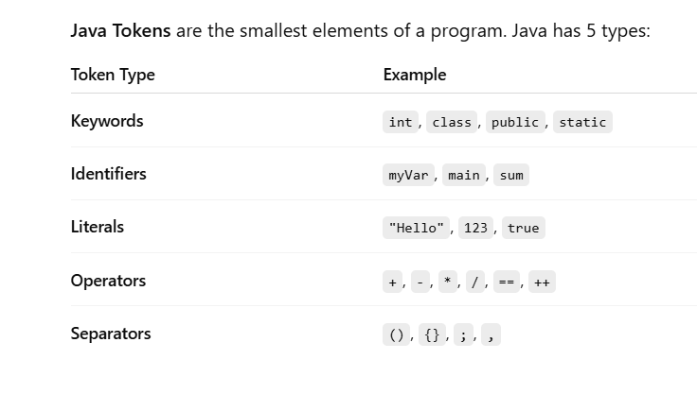

Literals 🡺 variable jo value ko assign krte hai usko hi bolte hai literals ex int x = 10; 10 literals hai

**3. Data Type Compatibility**

Java is strongly typed, and types must be compatible.  
**Implicit Conversion:** small → large  
**Explicit (Casting):** large → small

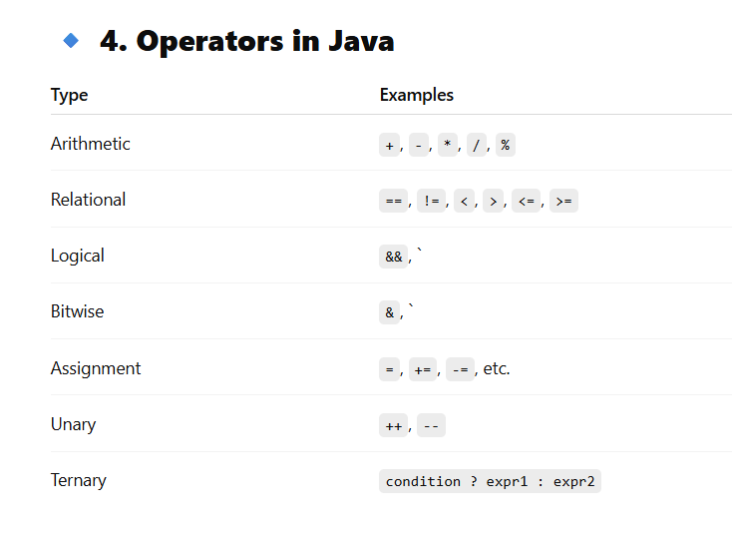

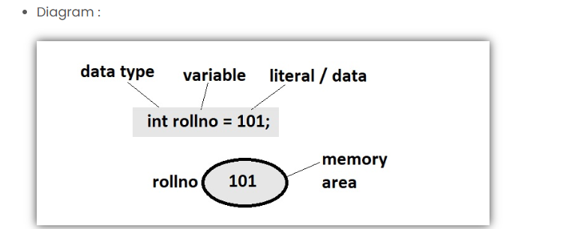

**6. Null Literal**

* **Null Literal represents the absence of a value for an object reference.**
* **Examples of Null Literal is :-**
  1. **String str = null;**
* **Rules for Null Literals are:**
  1. **null can only be assigned to reference types, not primitive data types.**

**Underscores in Numeric Literals (Java 7+)**

* **We can use underscores in numeric literals to improve readability.**
* **For example :-**
  1. **int million = 1_000_000;**
  2. **double pi = 3.141_592_653;**
* **Rules to use Underscores in Numeric Literals :**
  1. **Underscores cannot be used at the start or end of the literal, or next to a decimal point.**

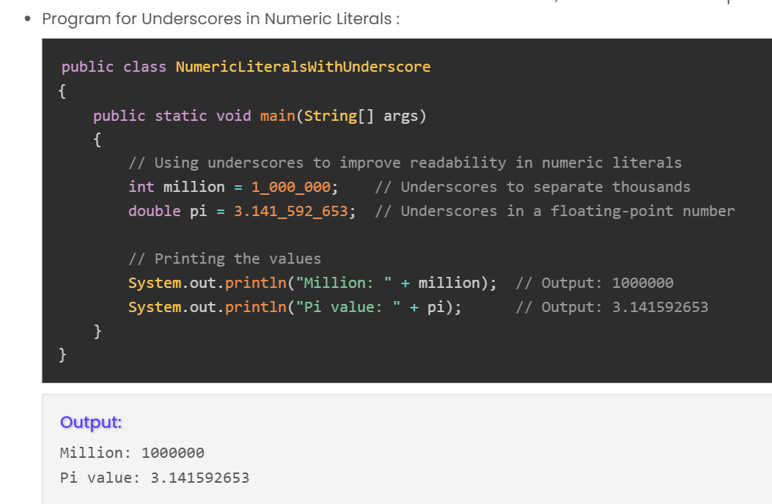

**instanceof:** Used to check if an object is an instance of a particular class or interface.

* **MCQ Connection:** Question #11 (b instanceof A) uses this to check type relationships, crucial in OOP discussions. 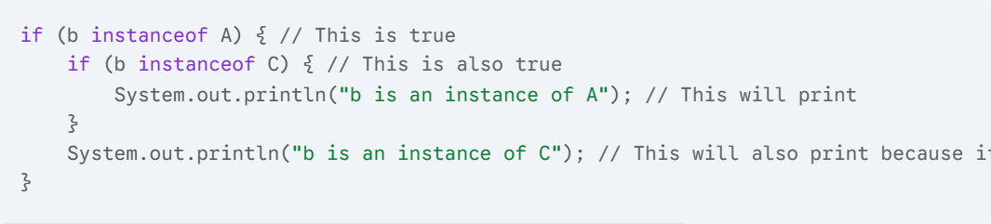

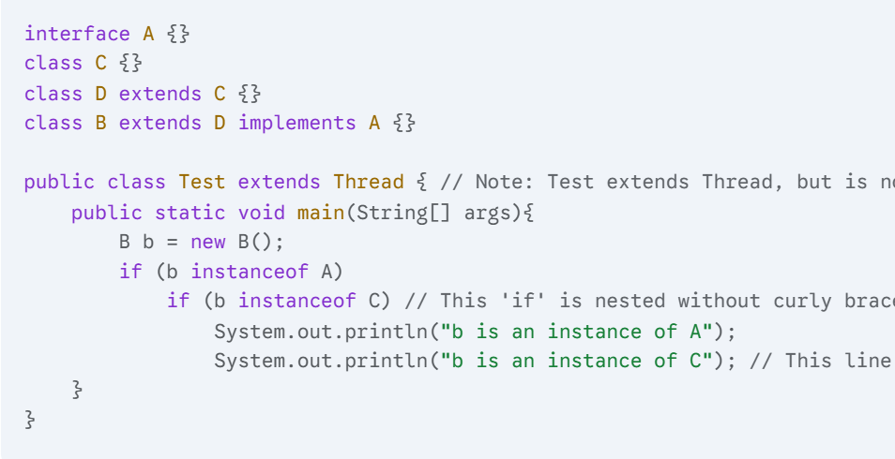

Instanceof ye bata hai ki B jo hai chid class hai parent class ka D ka ki nhi ye interface ke liye bhi kaam krega aurf super class hoga to bhi jaisa ques me hai

**Final Output:🡺**b is an instance of A 🡺b is an instance of C

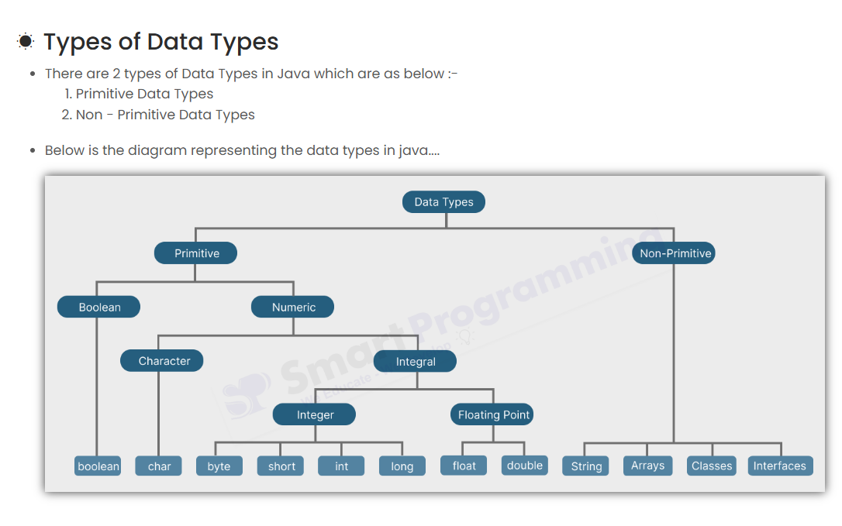

1. Primitive Data Types

* Primitive data types are pre-defined data types.
* There are total 8 primitive data types in Java i.e. boolean, char, byte, short, int, long, float and double.
* Primitive data types have fixed memory sizes for example char always occupies 2 byte of memory, int occupies 4 byte of memory etc.

2. Non-Primitive Data Types

* Non-Primitive data types are user-defined or derived data types.
* Non-Primitive data types examples are Strings, Arrays, classes, interfaces etc.
* Non-Primitive data types does'nt have fixed memory sizes, they depends on the data or objects they reference.  
  For example, a String object’s memory usage depends on the string's length.

KEyWords

* There are total **50 keywords** in Java, in which **48 keywords** are actively used in programming and **2 reserved words** (goto and const) that are not currently used in java.
* true, false and null are not keywords, they are literals (reserved words).

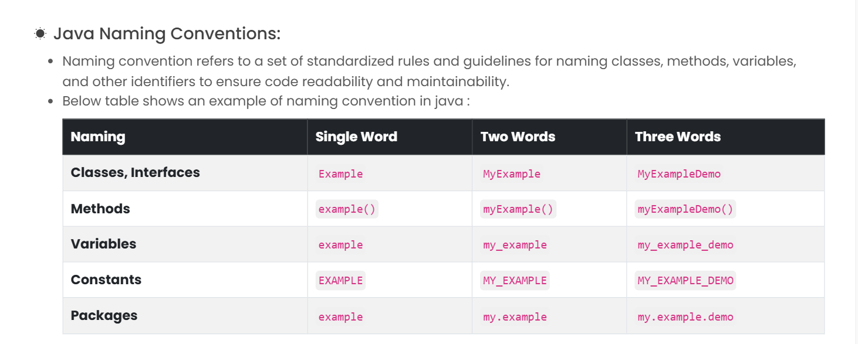

* Java is **strongly** Object Oriented Language but **not purely** Object oriented because java as primitive data types and static concept which is not related or tied to objects
* Smalltalk, Ruby, Scala etc are purely object oriented languages

# Static Variable

How many copies of a static variable exist for a class? 🡺Only one copy per class

What happens if you access a static method using an object?

a) Compile-time error  
b) Runtime exception  
c) Works, but not recommended  
d) It calls constructor first

**Answer:** c) Works, but not recommended  
**Explanation:** You can access static members using an object, but it's not the standard way.

**🡺Objects are created in heap memory.**

**Which of these can be overloaded?**

**a) Static method  
b) Constructor  
c) Instance method  
d) All of the above**

**Answer: d) All of the above  
Explanation: Java allows overloading static methods, constructors, and instance methods.**

**🡺the default value of a reference variable if not initialized is🡺 null**

# OOPS

What is Class in Java ?

* Class does not occupy memory (but objects occupies memory).
* **NOTE :** Class metadata (such as the number of variables, variable names, method names, constructors, etc.) is stored in the Method Area.

**Object occupies memory** - When an object is created (new ClassName()), it gets memory allocated in the heap.

 What is Constructor in Java ?

* A constructor in Java is a **special type of method used to initialize objects**.
* It is called when an instance of the class is created or say, when an object of a class is created.
* Whenever an object is created using the new keyword, at least one constructor is called.
  + Note : **Constructors are not used to create an object**, they are only used to initialize an object.
* A constructor **does not have a return type** (not even void).
* Constructors **can have any access modifier** (public, private, protected or default) but **cannot have non-access modifiers** like static, final, abstract etc.
* Types of relationships between classes in Java:
  + **Association** (HAS-A relationship normal)(**Aggreation**🡺weak “Has a ”relationship ex department has Professors) and **composition**(strong Has -a relation ex House has room)
  + **Dependency** (USES-A relationship)
  + **Inheritance** (IS-A relationship)

 Association (HAS-A relationship)

* **Definition :**
  + Association is a relationship where **one class uses or interacts with another class** by **holding a reference** to it. It represents a HAS-A relationship in object-oriented programming.
* **Example :**
  + Student ***HAS-A*** Address
  + Car ***HAS-A*** Engine.
  + Laptop ***HAS-A*** Processor.

 Dependency (USES-A relationship)

* + **Definition :**
    - Dependency is a relationship where **one class uses another class temporarily to perform a specific task**. This means the dependent object is often used **within a method**, rather than being stored as an instance variable.
    - It represents a **USES-A** relationship.
    - The dependency is typically **short-lived**, existing only during the execution of a method.
  + **Example :**
    - Teacher ***USES-A*** Whiteboard
    - Office Worker ***USES-A*** Printer

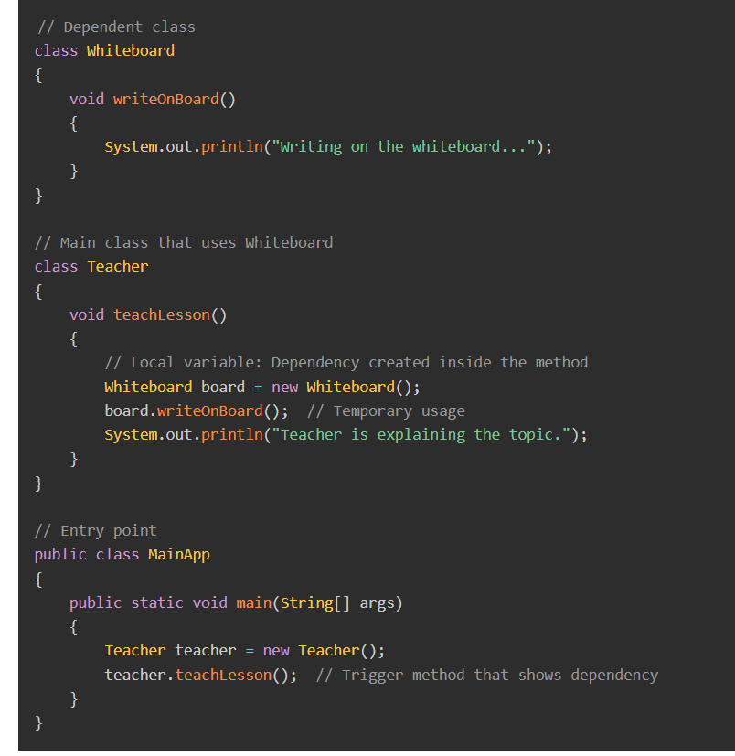

 Types of Polymorphism in Java :-

Polymorphism allows🡺One interface for multiple actions

1. ***Compile-Time Polymorphism***
   * It is also known as *Static Binding* or *Early Binding*.
   * It is achieved by *Method Overloading* or *Operator Overloading*.

imp🡺In compile-time polymorphism, the *Java compiler* decides at **compile time** which ***overloaded*** *method* or ***operator*** to invoke based on the *method signature* and *reference type*.

***2 Runtime Polymorphism***

* + It is also known as *Dynamic Binding* or *Late Binding*.
  + It is achieved by *Method Overriding*.
  + In runtime polymorphism, the *JVM (Java Virtual Machine)* decides at runtime which *overridden method* to invoke based on the *actual object* (not the reference type).

• **final , static , private methods cannot be overridden.**

If a subclass has a static method with the same signature as a static method in its superclass, it's called **method hiding**, not overriding. The call depends on the reference type, not the object type

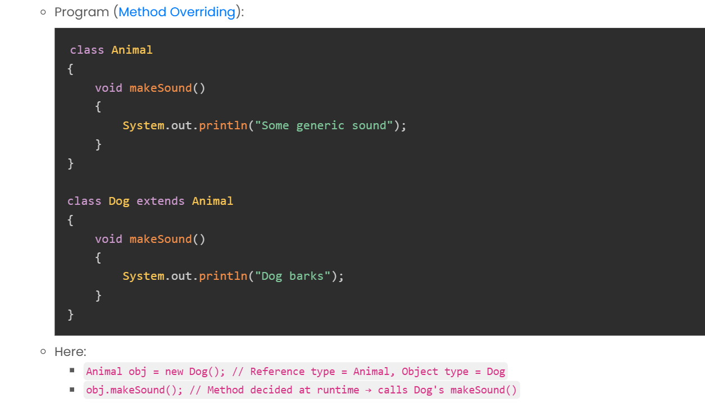

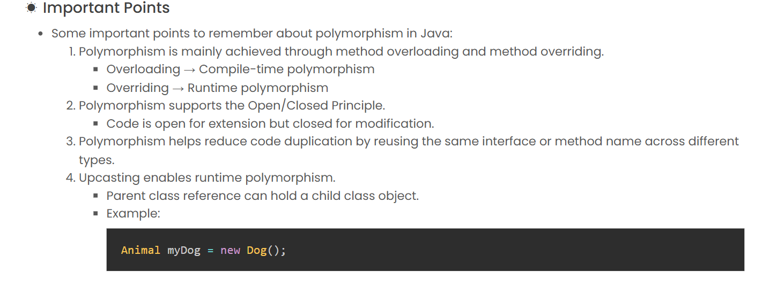

Animal myDog = new Dog() 🡺 run time polymorphism hai Overriding ka concept

# Abstraction in Java

* Abstraction is a concept of :
  + **hiding internal implementation details** and **howing only the essential features** to the user.
* **How to achieve Abstraction :-**
  + We can achieve Abstraction by two ways:
    - Using **Abstract Classes**
    - Using **Interfaces**

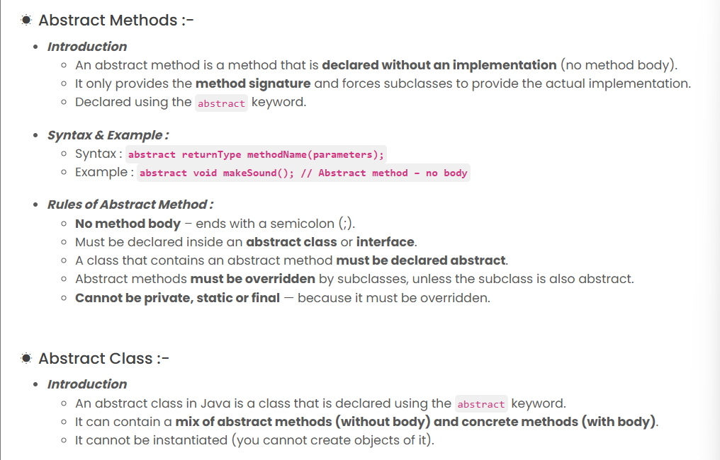

* **:** Abstract classes can contain static methods.
* ***Rules of Abstract Class :***
  + Must be declared using the abstract keyword.
  + Can contain **both abstract and concrete methods**.
  + **Cannot be instantiated** directly.
  + Subclass must **override all abstract methods** or be declared abstract itself.
  + Can have **constructors, static methods and final methods**.
  + Can **extend another class** and **implement interfaces**.

### **Q1.** What is true about abstract classes in Java?

a) It can be instantiated directly  
b) It must have at least one abstract method  
c) It cannot have non-abstract methods  
d) It can have constructors 🡺and

**a) It can be instantiated directly**  
❌ **False**  
An **abstract class cannot be instantiated directly**. That’s its key property — it serves as a *blueprint* and must be **extended** by a subclass.

**b) It must have at least one abstract method**  
❌ **False**  
An abstract class **can** have **zero** abstract methods. You might make a class abstract just to **prevent instantiation** or to provide **incomplete implementation**.

**It cannot have non-abstract methods**  
❌ **False**  
An abstract class **can have both**:

* abstract methods (without body)
* concrete methods (with body)

**d) It can have constructors**  
✅ **True**  
Yes, **abstract classes can have constructors**.  
Although you can’t create objects directly from them, these constructors are **invoked** when a subclass object is created.

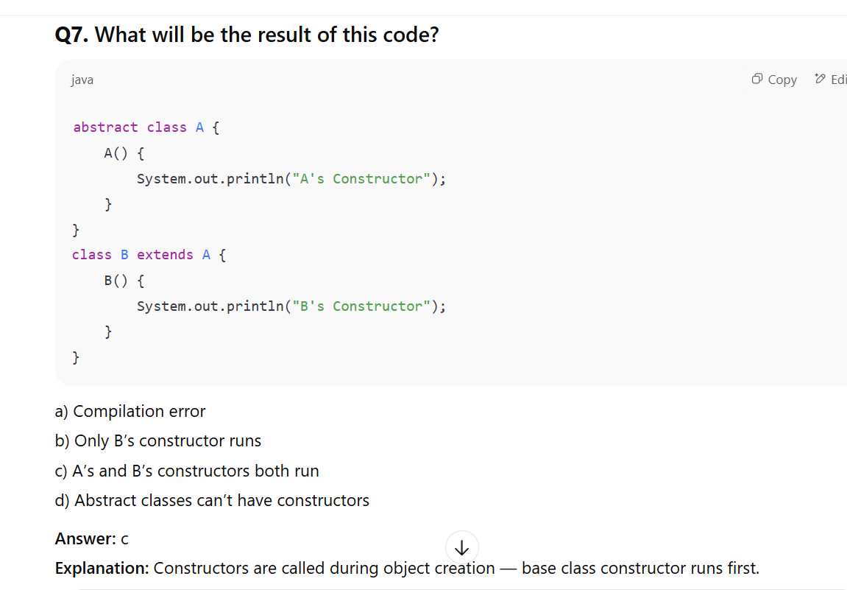

# Interface in Java

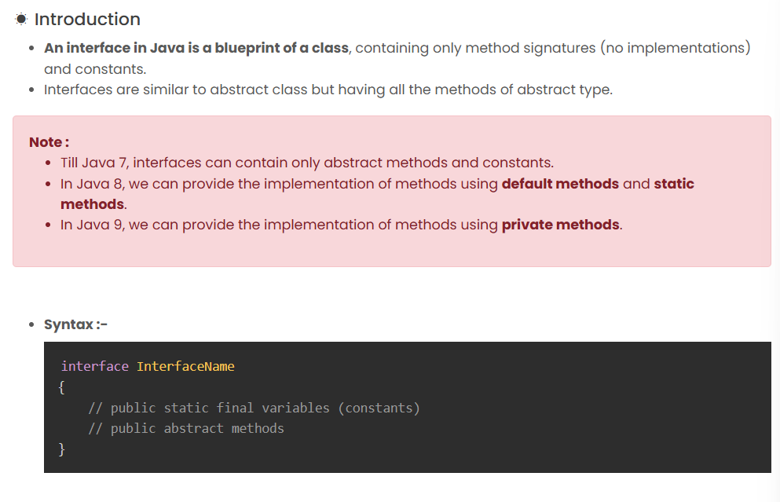

Functional interfaces have **only one abstract method** (e.g., Runnable, Comparable).

 Use of Interfaces :-

1. Used to achieve 100% abstraction in Java.
2. Used to define a common behaviour across unrelated classes.
3. Used to achieve multiple inheritance in Java.
4. **Used to achieve loose coupling in our code.**
5. Used extensively in frameworks, APIs, and design patterns (e.g., DAO, Service Layer).

### **Q1.** What is true about interfaces in Java?

a) Interfaces can have constructors  
b) Interfaces can extend classes  
c) Interfaces can extend multiple interfaces  
d) Interfaces can be instantiated

**Answer:** c  
**Explanation:** Interfaces **can extend multiple interfaces**, but cannot have constructors or extend classes.

|  |  |  |
| --- | --- | --- |
| Class implements multiple interfaces | ✅ Yes | No ambiguity |

|  |  |  |
| --- | --- | --- |
| Interface extends multiple interfaces | ✅ Yes | Common in Java design |

.

**Q3. What is the default access modifier for interface methods?**

a) private  
b) protected  
c) public  
d) no modifier

**Answer:** c  
**Explanation:** Interface methods are implicitly public.

### **Encapsulation in Java**

Introduction

* Encapsulation is the **mechanism of binding data (variables) and actions (methods) into a single unit**, called a class.
* Technically, every class is an example of encapsulation.

Rules for Encapsulation :-

* **1. Private Variables :**
  + Declare variables as **private** so that they cannot be accessed directly from outside the class.
* **2. Public Getter & Setter Methdos :**
  + Provide **public getter and setter methods** to access and modify the private variables.

**What are Reference Data Types?**

* Unlike primitive data types (which hold the actual value), reference data types hold **references** (memory addresses) to objects.
* • **Examples:** Classes (String, Dog, Scanner), Interfaces (Runnable, Comparable), Arrays (int[], String[]).
* • **Default Value:** The default value for any uninitialized reference variable (instance or static) is null. null means "no object is being referenced."

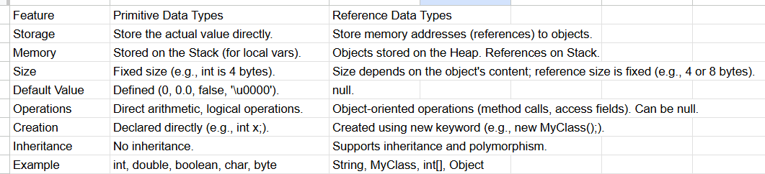

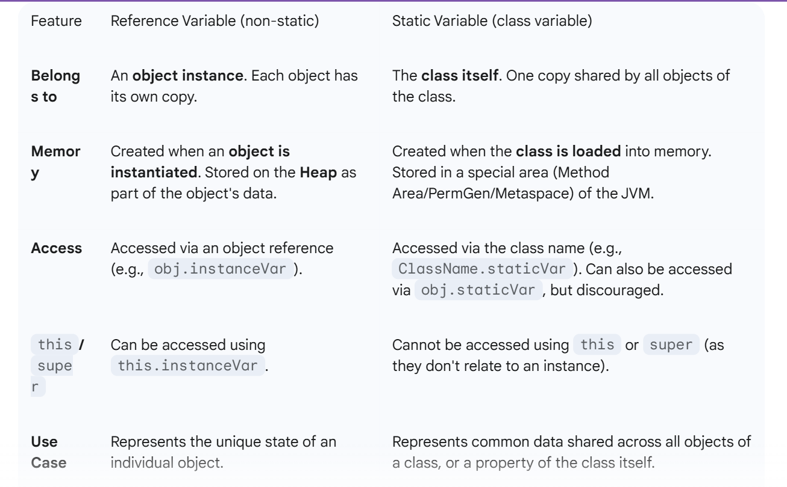

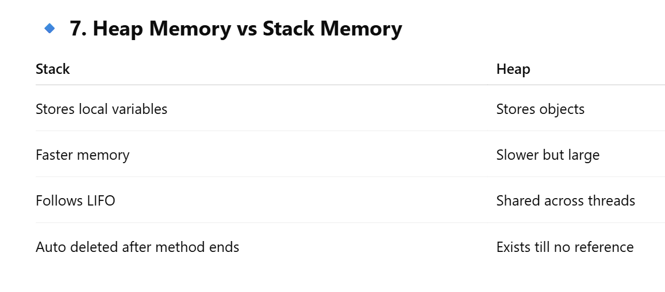

**5.2 Pass by Value vs. Pass by Reference**

This is a very common point of confusion, and it's essential to get it right.

**Java is ALWAYS Pass by Value.**

* **Pass by Value (for Primitives):** When you pass a primitive data type (like int, double, boolean, char) to a method, a *copy* of the actual value is passed. The method works on this copy. Any changes made to the parameter *inside* the method will **not** affect the original variable outside the method.

**Pass by Value (for References):** When you pass an object (a reference variable) to a method, a *copy of the memory address (the reference)* is passed. Both the original reference variable and the method's parameter now point to the **same object** on the heap.

* If you modify the object's state *through* the parameter reference inside the method, the changes **will be visible** outside the method, because you are modifying the *same object*.
* However, if you reassign the parameter reference to point to a *new object* inside the method, the original reference variable outside the method will **not** be affected; it will still point to the original object.

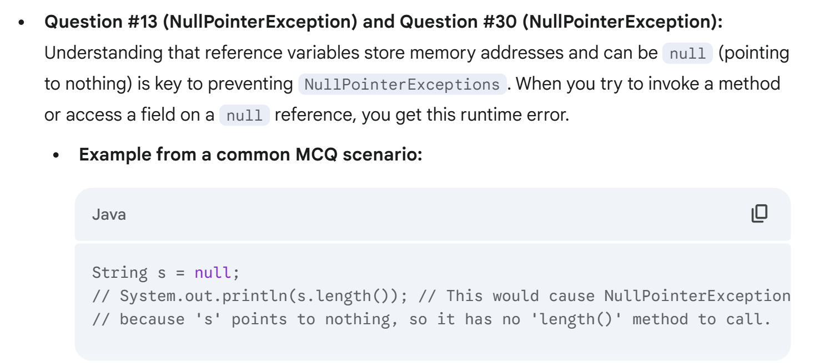

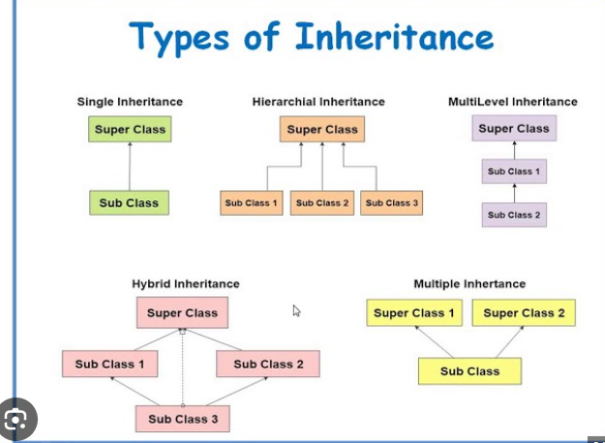

Constructors are not inherited, so can't be overridden

THIS keyword

**this keyword:**

* **Refers to:** The current instance (object) of the class.
* **Usage:**
  1. **To differentiate instance variables from local/parameter variables with the same name:**
  2. **To invoke the current class's constructor (constructor chaining):** this()
  3. **To return the current class instance:** return this;
  4. To pass the current object as an argument to a method.

What does this keyword refer to?

a) Parent object  
b) Any object  
c) Current object  
d) None

**Answer:** c) Current object  
**Explanation:** Used for current class object reference.

**super keyword:**

* **Refers to:** The immediate superclass of the current object.
* **Usage:**
  1. **To invoke the immediate superclass's constructor (super()):**
     + Must be the first statement in the constructor.
     + If you don't explicitly call super() or this() in a constructor, the compiler automatically inserts a default super() call (to the no-arg constructor of the superclass).
     + Crucial for ensuring the superclass part of the object is properly initialized.

**To access an overridden method of the immediate superclass:**

* When a subclass overrides a method, super.methodName() allows you to call the superclass's version of that method.

**To access a hidden field of the immediate superclass:**

* If a subclass declares a field with the same name as a field in its superclass, the superclass's field is "hidden." super.fieldName can be used to access it.

🔹 Upcasting and Downcasting in Java

**✅ 1. Upcasting (✅ Common in real code and safe)(Compile time error)**

**Definition:**  
Assigning a subclass object to a **superclass reference**.

✔ This is **automatic** and **safe** — no explicit cast required.  
✔ Only the **methods of the parent class** are accessible through the reference.

**Access Limitations:** When an object is upcasted, you can only access the members (fields and methods) that are defined in the **superclass type** (the type of the reference variable), even if the object itself is of a subclass type and has more specific members. However, if a method is *overridden* in the subclass, the *overridden version* from the actual object type will be invoked at runtime (runtime polymorphism).

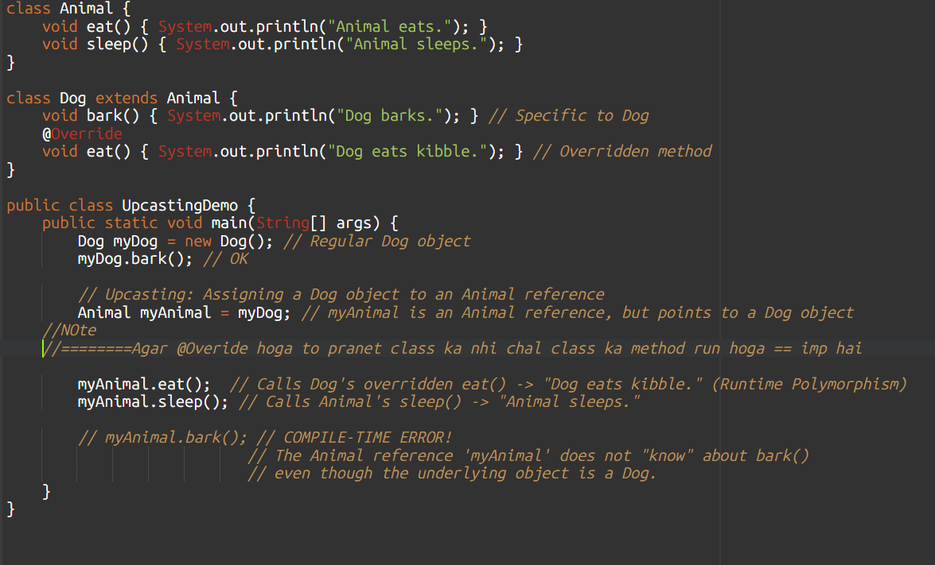

Agar @Overide hoga to pranet class ka nhi child class ka method run hoga

**2. Downcasting (⚠ Risky and must be done explicitly)(runtime error)**

**Definition:**  
Casting a superclass reference **back to a subclass reference**.

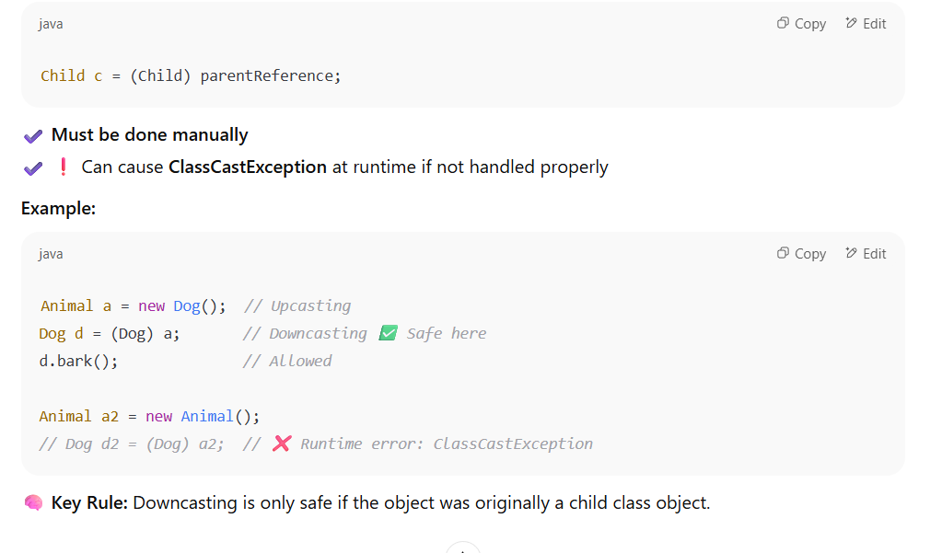

Another example but imp 🡺Always use **instanceof** before downcasting to avoid ClassCastException

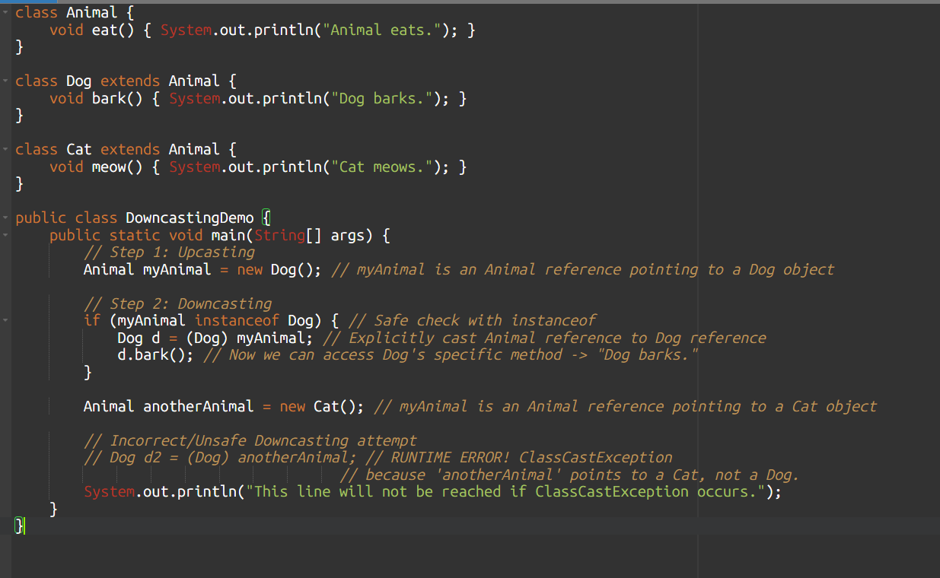

**Q1. Which of the following is true about upcasting?**

a) Requires explicit type casting  
b) Can lead to ClassCastException  
c) Allows access to only parent class members  
d) Cannot be performed in Java

**Answer:** c  
**Explanation:** Upcasting is implicit and safe, but only parent members are accessible.

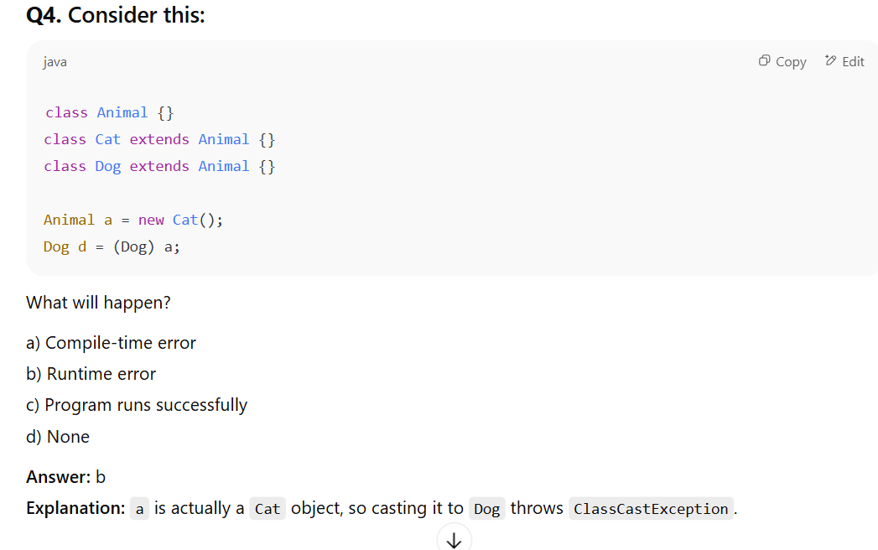

**Q6. Which is a common use of upcasting?**

a) Memory management  
b) JVM optimization  
c) Polymorphism  
d) Thread handling

**Answer:** c  
**Explanation:** Upcasting enables runtime polymorphism.

**Q8. Which of the following is NOT a benefit of upcasting?**

a) Code reusability  
b) Reduced object creation  
c) Polymorphic behavior  
d) Code scalability

**Answer:** b  
**Explanation:** Upcasting doesn't reduce object creation — it's about reference types, not instances.

**Q9. Downcasting an object that was not originally upcasted will lead to:**

a) Compile error  
b) Runtime error  
c) Logical error  
d) None

**Answer:** b  
**Explanation:** Runtime error (ClassCastException) if downcasted object wasn't upcasted.

# ✅ Session 9 & 10:

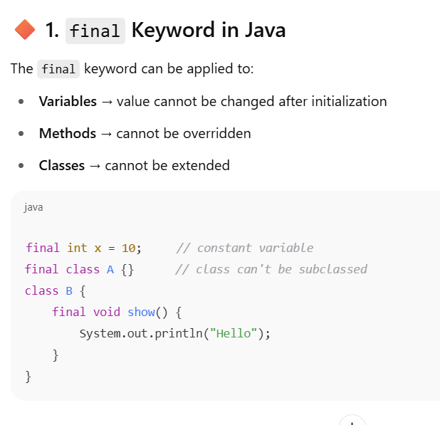

**What is true about a final class?**

**Options:**  
a) It can be extended  
b) It cannot be instantiated  
c) It cannot be subclassed  
d) It must implement an interface

In Java, the keyword final when applied to a **class** means:

🔒 **The class cannot be extended (i.e., no subclass can inherit from it).**

This is often done to prevent alteration of the class behavior through inheritance.

**🚫 Let's go through the incorrect options:**

* **a) It can be extended** → ❌ *Wrong*, because final classes **cannot** be extended.
* **b) It cannot be instantiated** → ❌ *Wrong*, that’s true for **abstract** classes, not final ones. A final class can be instantiated like any normal class.
* **d) It must implement an interface** → ❌ *Wrong*, a final class **may or may not** implement an interface — it's not mandatory.

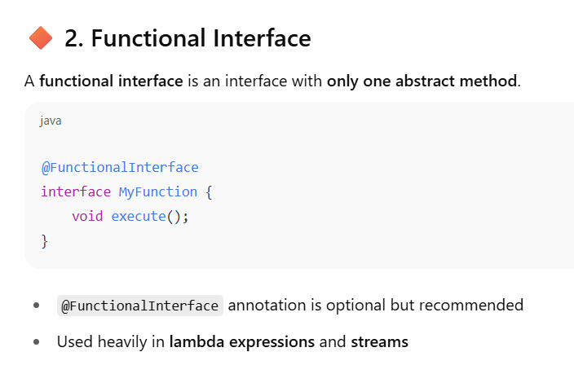

**Multiple default or static methods**

**But only one abstract method**

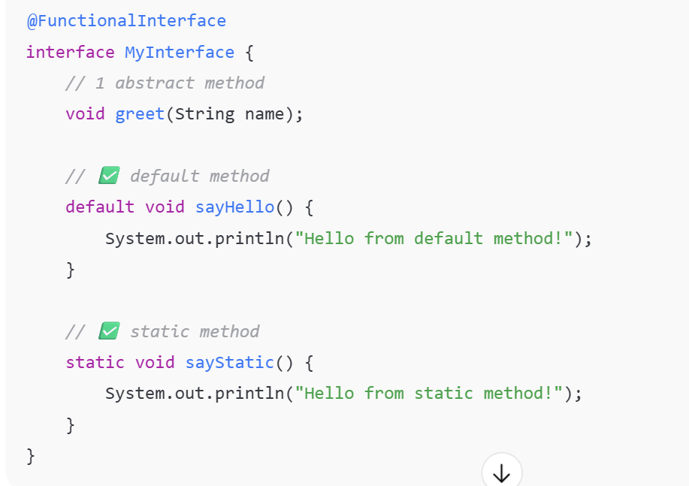

**Q10. Which interface is marked with @FunctionalInterface in Java?**

a) Runnable  
b) Thread  
c) Serializable  
d) Object

**Answer:** a  
**Explanation:** Runnable has **only one abstract method run()**, making it a functional interface.

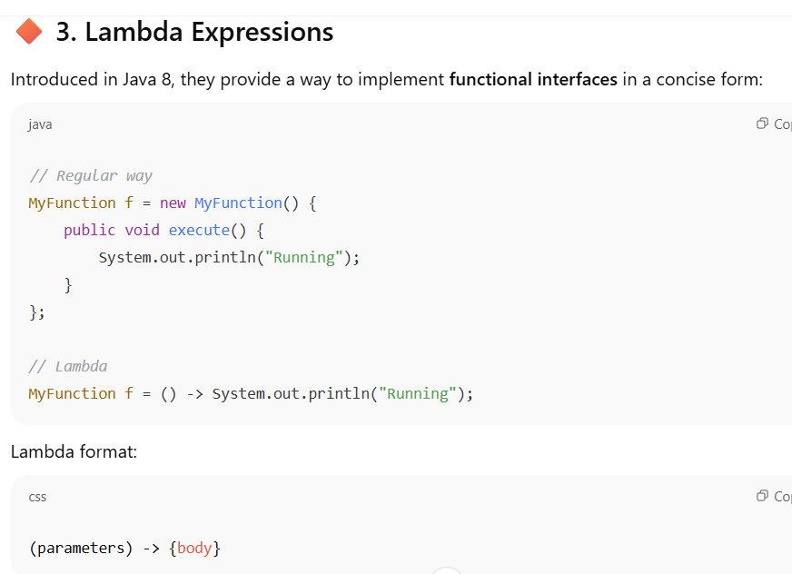

**🔶 4. New Interface Features**

| **Version** | **Feature** |
| --- | --- |
| Java 8 | default & static methods |
| Java 9 | private methods in interface |
| Java 11 | enhancements to APIs, not core interface changes |

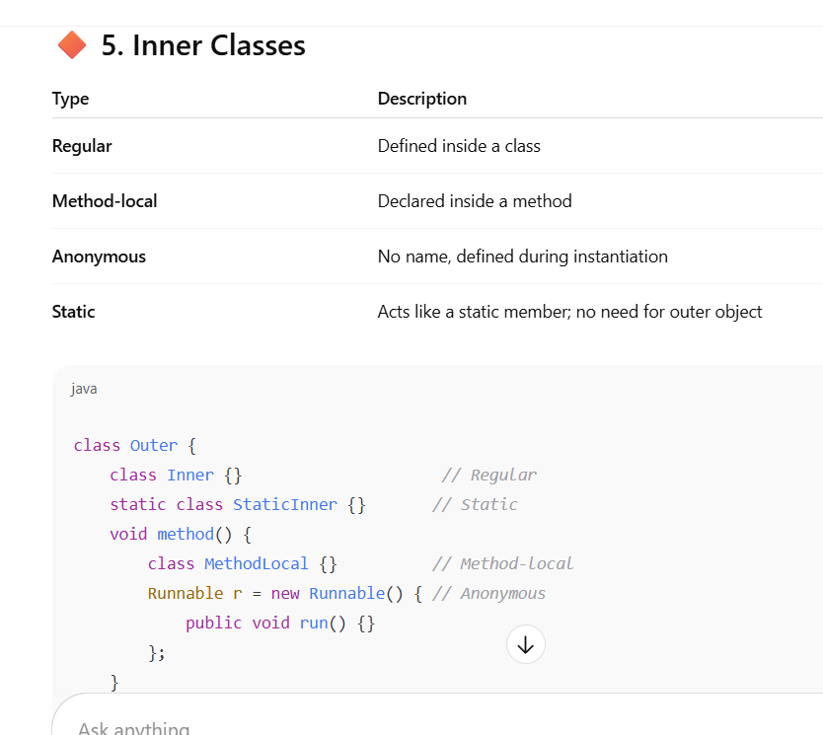

**Enum (Enumeration)**

* **Definition:** A special "class" in Java that represents a fixed set of named constants.
* **Purpose:** To define a collection of related constants (like days of the week, months, colors, cardinal directions).
* **Benefits:**
  + **Type Safety:** Prevents invalid values. You can't assign an arbitrary string to an enum type.
  + **Readability:** Clearer code than using int constants (0, 1, 2).
  + **Built-in methods:** Enums come with useful methods like name(), ordinal(), valueOf(), values().
  + Can have constructors, methods, and fields, just like a regular class (but with specific rules).
* • "must be defined as first statement" - **TRUE** (syntax rule).
* • "is an object of type enum" - **TRUE** (fundamental nature).
* • "**enum constants are implicitly **public static final** in Java.
* • "ordinal value starts from 1" - **FALSE** (starts from 0).

|  |
| --- |
| * abstract |

|  |
| --- |
| ❌ Not allowed — enums cannot be abstract |

* + The .ordinal() method returns the **position (index)** of an enum constant **based on its declaration order**, starting from **0**.
* Enums **cannot be extended**
* • They **extend java.lang.Enum**
* • You can’t create an enum with new
* • Enum values are **instances** of the enum class

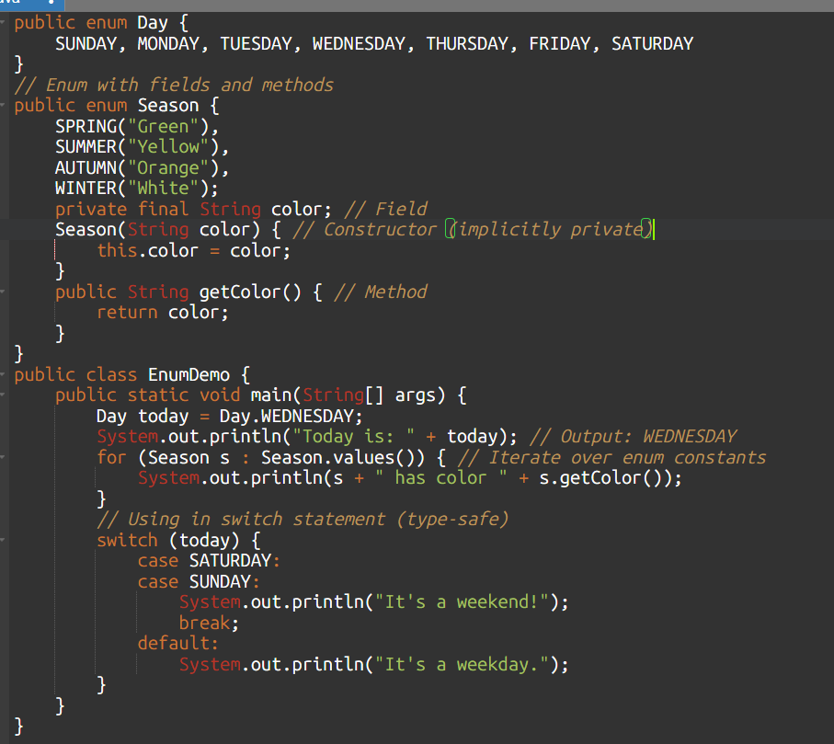

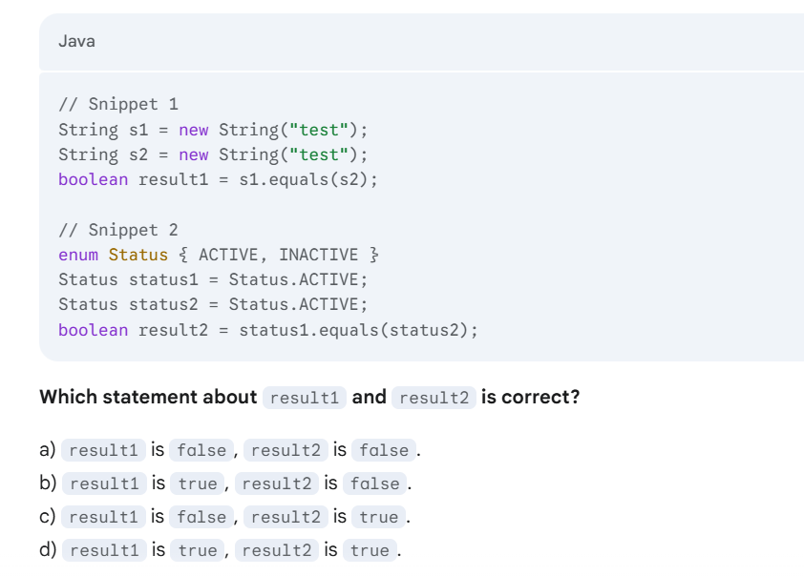

* **Snippet 1 (Strings):** s1 and s2 are distinct String objects, but their equals() method (which the String class **overrides**) compares their **content** ("test"). Since the content is the same, result1 is true.
* **Snippet 2 (Enums):** status1 and status2 both point to the *exact same unique instance* of the ACTIVE enum constant. The Enum class's equals() method (which behaves like ==) compares **object references**. Since they refer to the same object, result2 is true.

**In short:** String.equals() checks value, while Enum.equals() (and == for enums) checks if they are the *exact same instance*, which for enums, effectively also means checking their value due to their singleton nature.

| **Concept** | **Trick** |
| --- | --- |
| Default method | Looks like abstract method but has body |
| Static interface method | Can’t be called on object, must use interface name |
| Private method | Only accessible within the interface |
| Anonymous class | No name, no constructor |
| Regular inner class | Needs outer object to be instantiated |
| Static inner class | Can’t access outer non-static data |

**Anonymous inner classes** are implicitly final, meaning they cannot be extended further.

**An anonymous inner class** is instantiated exactly once, at the point of its declaration. That single instance is what you work with. You cannot create multiple instances by name because it doesn't *have* a name.

**access the members of its outer class**

# ✅ Access Modifiers, Packages, Static Imports & Constructor Chaining

**9.1 Access Modifiers**

Access modifiers in Java control the visibility and accessibility of classes, fields (variables), methods, and constructors. They determine from where (within the same class, same package, or different packages) a member can be accessed.

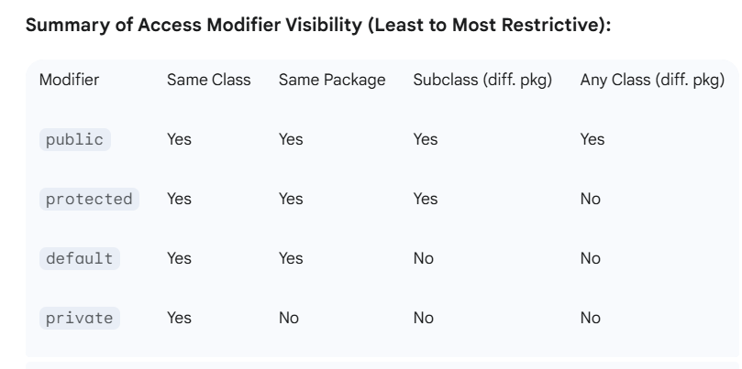

**protected:**

* **Visibility:** Members declared protected are accessible:
  1. **Within the same package.**
  2. **From subclasses in *any* package.** (But only through inheritance; you can't access protected members of an *unrelated* object from a different package, even if you are a subclass).
* protected members can only be accessed outside the package via inheritance.
* protected allows access in same package and also via subclass in different package.

**2. Packages & Import Statements**

* **Packages** group related classes together.
* package keyword must be the **first line** in your Java file.
* To use classes from other packages → import packageName.ClassName;

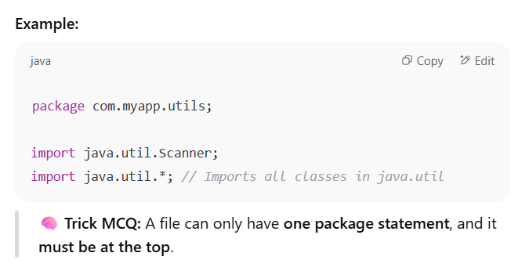

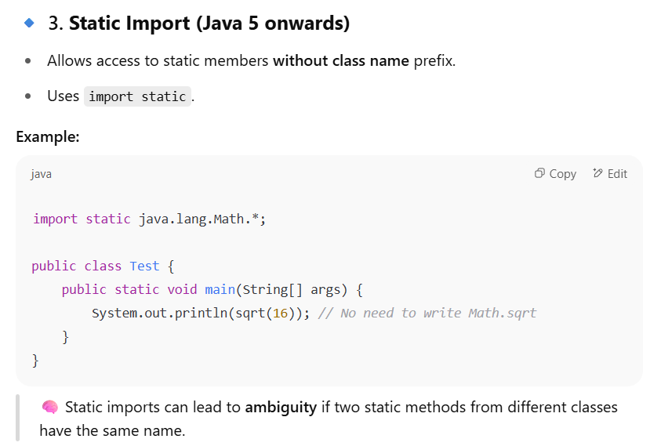

Exam 🡺import static java.lang.Math.max; agar import static java.lang.Math.max();to wrog hai

**Constructor Chaining**

* **Definition:** The process of one constructor calling another constructor within the same class or a superclass.
* **Purpose:** To reduce code duplication in constructors and ensure proper initialization.
* **Keywords:**
  + this(): Calls another constructor within the **same class**.
  + super(): Calls a constructor of the **immediate superclass**.
* **Rule:** Both this() and super() calls **must be the very first statement** in a constructor. A constructor can have *either* this() *or* super(), but not both. (If neither is present, the compiler implicitly inserts super(); to call the no-arg superclass constructor).

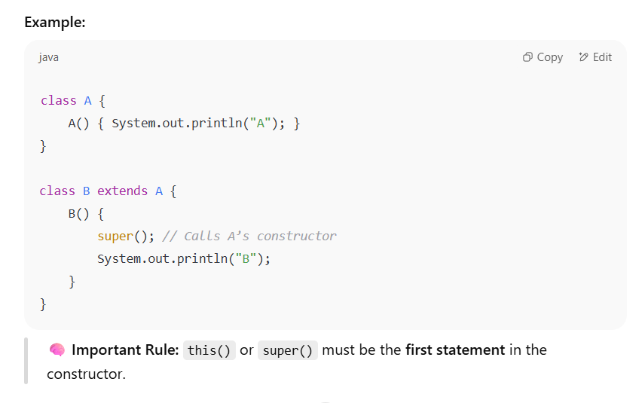**🔹 5. Accessing Protected Members Outside the Package**

To access protected members **outside a package**, you must **inherit the class**.

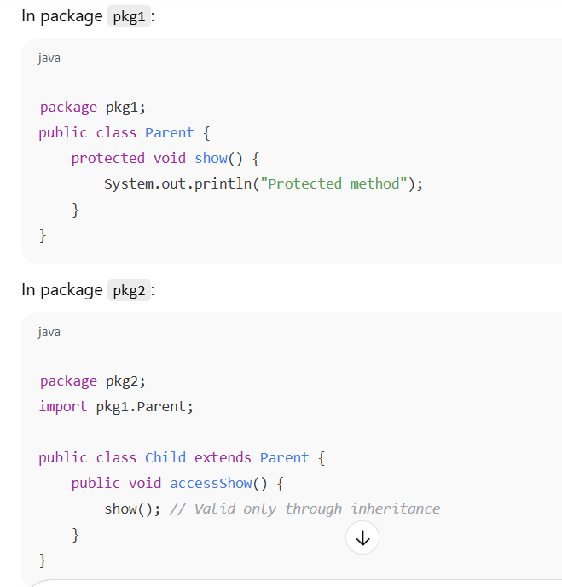

# ✅ Garbage Collection in Java

**🔹 What is Garbage Collection?**

Garbage Collection (GC) is the process by which **Java automatically reclaims memory** used by objects that are **no longer reachable** or needed by the program.

Java uses an **automatic garbage collector**, so you don't need to manually deallocate memory like in C/C++.

**🔹 Why is Garbage Collection Important?**

* **Avoids memory leaks**
* **Improves performance**
* **Ensures efficient use of heap memory**

**🔹 JVM Components Involved**

* **Heap Memory**: Where objects are stored
* **Garbage Collector**: A background thread that checks for unreachable objects
* The **Mark and Sweep** algorithm is a fundamental garbage collection algorithm.
* **Mark phase:** Identifies all reachable objects.
* **Sweep phase:** Reclaims memory occupied by unreachable objects.
* Other models might exist or be components, but "Mark and Sweep" is a well-known and widely implemented garbage collection algorithm in Java.

**🔹 Requesting JVM to Perform GC**

You can request garbage collection using:

System.gc(); // Suggests JVM to perform garbage collection

Runtime.getRuntime().gc(); // Another way to request GC

📌 **Note**: This is only a *request*. JVM may or may not run GC immediately.

**System.gc();**: This is the most common way to hint to the JVM that it's a good time to run the garbage collector.

1. **Runtime.getRuntime().gc();**: This achieves the same purpose as System.gc(). System.gc() internally calls Runtime.getRuntime().gc().

**🔹 How an Object Becomes Eligible for GC**

1. **Nulling a Reference**

Student s = new Student();

s = null; // Eligible for GC

1. **Reassigning a Reference**

Student s1 = new Student();

Student s2 = new Student();

s1 = s2; // The first object becomes unreachable

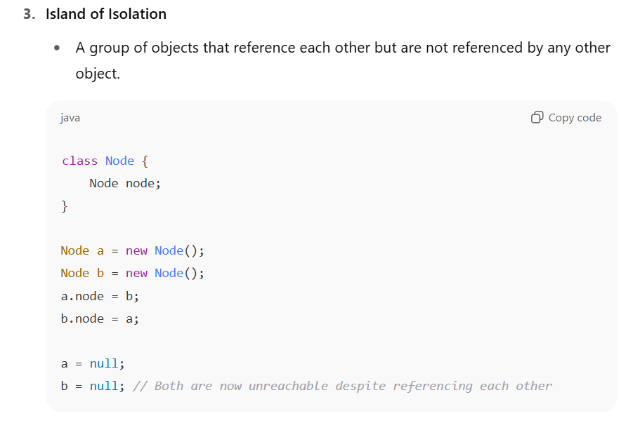

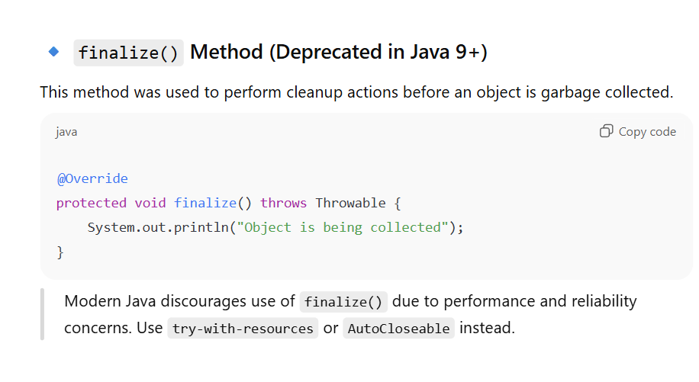

**finalize() Method**

* **What:** A special method that the Garbage Collector *may* call on an object just before it is actually garbage collected. It's declared in the java.lang.Object class: protected void finalize() throws Throwable.

**Modern Alternatives:**

* **try-with-resources (preferred for auto-closable resources):** For resources that implement AutoCloseable (like streams, database connections), this ensures they are closed deterministically.
* finalize() is deprecated in Java 9+ due to unpredictability.

# Static Blocks, Main Method, Varargs, Command-Line Arguments, final vs finally vs finalize

**Static Block**

* **What:** A block of code inside a class, declared with the static keyword. It's often referred to as a "static initializer block."
* **Purpose:** To initialize static variables or perform any one-time setup operations that need to happen when the class is loaded into memory.
* **Execution:** A static block is executed **only once**, when the class is first loaded into the Java Virtual Machine (JVM). It runs *before* the main method (if present) and before any objects of the class are created.
* Non-static (instance) methods *can* directly access static members (variables and methods) of the same class. This is because non-static methods operate on an object, and that object belongs to the class, so it has access to class-level members.
* Static methods can access other static members directly.
* Static import can access directly all the static members of class

**main Method**

* **What:** The entry point for any standalone Java application. The JVM begins execution from this method.
* **Signature:** It must have the exact signature: public static void main(String[] args).

**Variable Arguments (Varargs) (Java 5+)**

* **What:** A feature that allows a method to accept a variable number of arguments of a specified type. It's syntactic sugar over an array.
* **Syntax:** Use an ellipsis (...) after the data type in the parameter list.

**Command-Line Arguments**

* **What:** Arguments passed to a Java program from the command line when it is executed.
* **How:** These arguments are received by the main method as an array of String objects (String[] args). Each element in the args array corresponds to one argument provided after the class name.

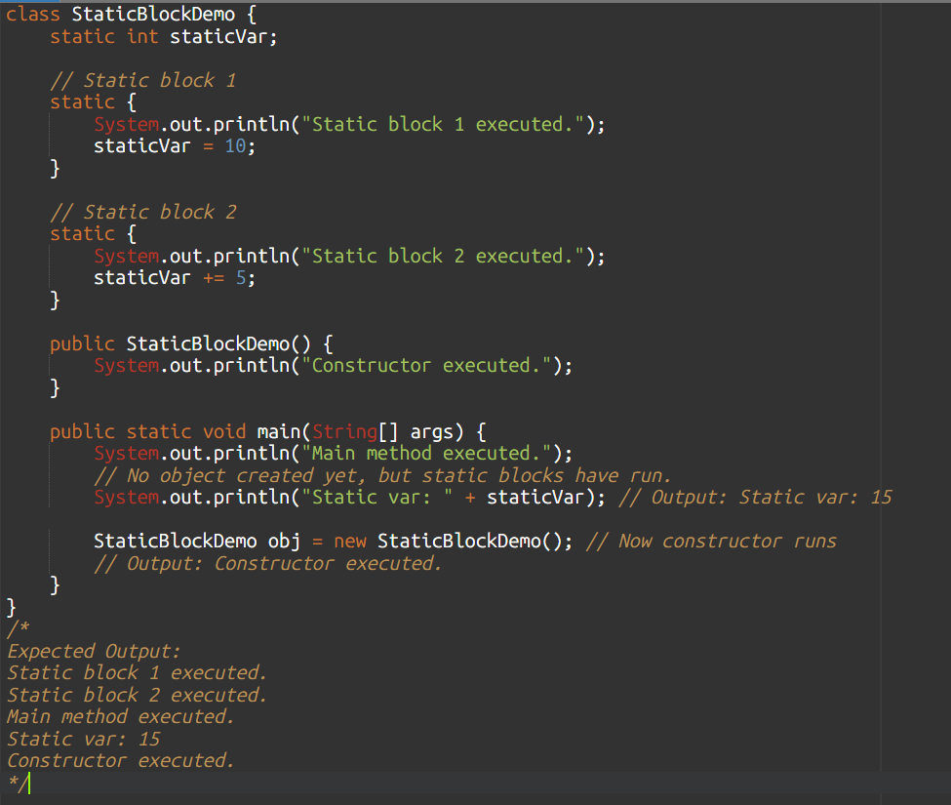

**Q7. Which of these is not a method in Integer?**

a) parseInt()  
b) toString()  
c) valueOf()  
d) toLowerCase()🡺toLowerCase() belongs to **String**, not Integer.

**final (Keyword):**

* **Usage:** Applies to variables, methods, and classes.
* **Meaning:** Immutability or unchangeability.
  + final variable: Its value cannot be changed once initialized (a constant).
  + final method: Cannot be overridden by a subclass.
  + final class: Cannot be extended/subclassed.

**finally (Block):**

* **Usage:** Associated with try-catch blocks for exception handling.
* **Meaning:** A block of code that is **always executed**, regardless of whether an exception occurred in the try block or was caught by a catch block. The only exceptions are if the JVM exits, or if System.exit() is called from within the try or catch block, or due to a power failure.
* **Purpose:** To ensure that critical cleanup code (like closing resources: files, database connections, network streams) is executed reliably.

**finalize() (Method):**

* **Usage:** A protected method of the Object class (deprecated since Java 9).
* **Meaning:** A method that the Garbage Collector *may* call on an object just before reclaiming its memory.
* **Purpose (Historical):** Intended for releasing unmanaged resources held by an object.
* **When:** Non-deterministic (JVM's discretion). **Strongly discouraged** due to unpredictability and performance issues. Replaced by try-with-resources or Cleaner.

**String Class((java.lang.String))**

**Key Features:**

* **Immutable: Once a String is created, it cannot be changed.**
* **Stored in a special area of heap memory called the String Pool.**
* **Supports concatenation, substring, comparison, and more.**

**gemini**

* **Immutability:** The most critical characteristic. Once a String object is created, its sequence of characters cannot be changed. Any "modification" creates a new String object in memory.
* **Thread-Safety:** Inherently thread-safe due to immutability. Multiple threads can read a String without synchronization issues.
* **Memory Impact:** Because operations like concatenation (+) create new String objects, frequent modifications (e.g., in a loop) can lead to a large number of discarded String objects, increasing garbage collection overhead.
* **String Pool Integration:** String literals are stored in the String Pool, an optimization we'll discuss next.

**StringBuffer Class:**

**• Thread-safe (uses synchronized methods)**

**• Used when multiple threads access a string**

* **Mutability:** Mutable. Its content can be modified in place without creating new objects.
* **Thread-Safety:** Thread-safe. All methods that modify the buffer are synchronized, ensuring only one thread can modify it at a time. This adds a performance overhead.
* **Memory Impact:** Efficient for frequent modifications because it operates on an internal, expandable character array. Reduces garbage collection.

**StringBuilder Class:**

* **Mutability:** Mutable. Its content can be modified in place, just like StringBuffer.
* **Thread-Safety:** Not thread-safe. Its methods are *not* synchronized.
* **Memory Impact:** Most efficient for frequent modifications in a single-threaded environment.
* **Performance:** Generally faster than StringBuffer due to the lack of synchronization overhead.
* **Faster** than StringBuffer
* **Not thread-safe** – use in single-threaded programs

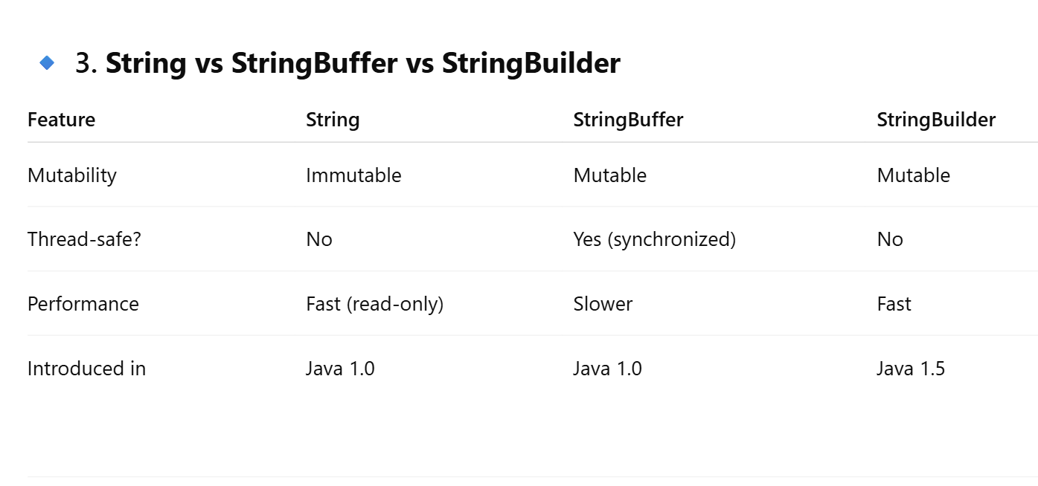

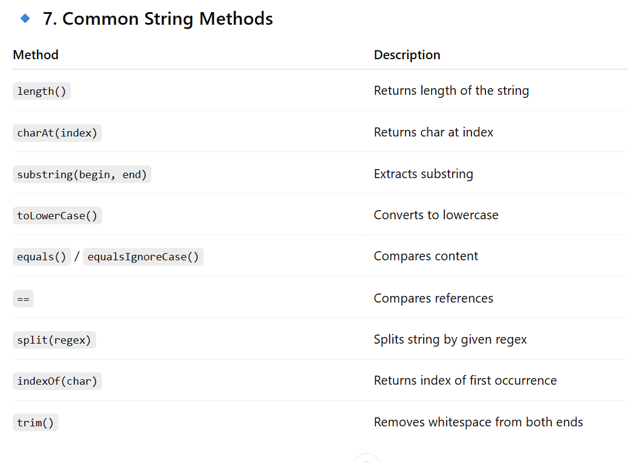

## ✅ **Session 13: Wrapper Classes and Constant Pools**

**🔹 1. What Are Wrapper Classes?**

In Java, **primitive data types** (int, float, boolean, etc.) are not objects. Sometimes we need to treat them as objects — especially when working with collections like ArrayList, which can only store objects.

To bridge this, Java provides **wrapper classes** in the java.lang package.

| **Primitive** | **Wrapper Class** |
| --- | --- |
| byte | Byte |
| short | Short |
| int | Integer |
| long | Long |
| float | Float |
| double | Double |
| char | Character |
| boolean | Boolean |

**🔹 2. Autoboxing & Unboxing**

* **Autoboxing:** Automatic conversion of a primitive type to its corresponding wrapper object.

int a = 5;

Integer obj = a; // autoboxing

* **Unboxing:** Automatic conversion from wrapper object to primitive type.

java

Integer b = 10;

int c = b; // unboxing

**🔹 3. Why Wrapper Classes?**

* Required when working with **Collections Framework** (ArrayList, HashMap)
* Provide **utility methods** like parseInt(), valueOf()
* Enable **null assignment** (not possible with primitives)

ArrayList<Integer> list = new ArrayList<>();

list.add(10); // primitive int 10 autoboxed to Integer

🡺Collections.emptySet() (and emptyList(), emptyMap()) return immutable, empty collections. They are useful for returning an empty collection without allocating new memory each time.

**🔹 4. Constant Pool (String & Wrapper)**

**✅ Integer Constant Pool**

Java caches Integer objects in the range **-128 to 127**.

Integer a = 100;

Integer b = 100;

System.out.println(a == b); // true

Integer c = 200;

Integer d = 200;

System.out.println(c == d); // false

Explanation:

* a and b refer to same object from the **Integer pool**.
* c and d are **outside the range**, hence separate objects are created.

✅ This rule applies to: Byte, Short, Integer, Long, and Character (0 to 127).

**🔹 5. Utility Methods of Wrapper Classes**

Example: Integer

Integer x = Integer.valueOf("123"); // creates Integer object

int y = Integer.parseInt("456"); // returns int

**🔹 6. Immutability of Wrapper Classes**

All wrapper classes are **immutable**. Once created, their value cannot be changed.

Integer a = 10;

a = 20; // new object created, 'a' now refers to new Integer

# ✅ Session 14: Exception Handling in Java

**🔹 1. What is an Exception?**

An **exception** is an **unexpected event** that occurs during the execution of a program, disrupting the normal flow.

**They are runtime phenomena.**

In Java, exceptions are **objects** that represent errors.

**🔹 2. Exception Hierarchy**

All exceptions are derived from the class Throwable:

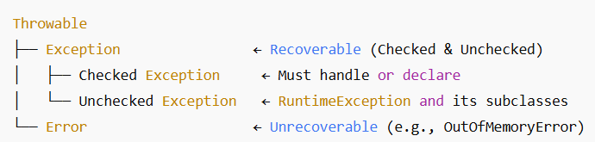

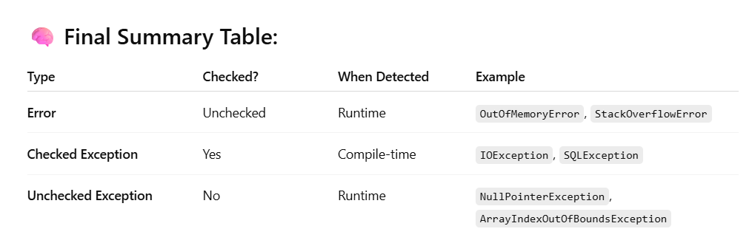

**Exception**: Recoverable (e.g., FileNotFoundException)

* **Error**: Unrecoverable (e.g., OutOfMemoryError)
* **RuntimeException**: Unchecked exceptions (e.g., NullPointerException)
* **Checked exceptions** are *detected* at compile-time (the compiler forces you to handle or declare them), but **they *occur* at runtime** (run time me bhut kam chances hai )(option me checked and unchecked me se run time ka ouch to unchecked hi lagana )

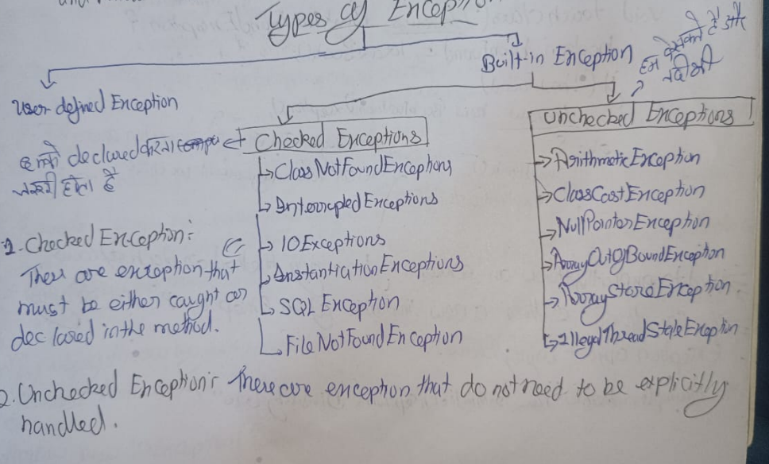

**🔹 4. try-catch-finally Syntax**

try {

// Code that may throw exception

} catch (ExceptionType e) {

// Handling code

} finally {

// Always executes (cleanup code)

}

* finally: Runs whether exception is thrown or not.
* try must be followed by **catch or finally**.
* finally block always survives except System.exit(0)

**🔹 5. Multiple Catch Blocks & Multi-Catch**

try {

// code

} catch (IOException e) {

// handle IO exception

} catch (Exception e) {

// generic catch

}

**Multi-Catch (Java 7+)**:

catch (IOException | SQLException e) {

// handle both

}

**🔹 6. throw vs throws**

* throw → Used to **throw** an exception object manually.
* throws → Declares **what exceptions a method can throw**.
* throws keyword is for satisfying javac instead of java it is compile-time construct to satisfying the compiler's requirement

void myMethod() throws IOException {

throw new IOException("File not found");

}

**🔹 7. Exception Propagation**

If a method doesn’t handle an exception, it **propagates** to the caller.

void methodA() {

methodB();

}

void methodB() {

throw new ArithmeticException();

}

* If not caught, the JVM handles it and terminates the program.

**🔹 8. User-defined Exceptions**

You can create custom exceptions by extending:

class MyException extends Exception { // Checked

MyException(String msg) {

super(msg);

}

}

# ✅ Session 17: java.io & java.nio Package

**Package**

**🔷 1. What is I/O in Java?**

* **I/O** stands for **Input and Output**.
* Java handles I/O through **streams**.
* These streams represent **data flow** between source and destination.

**🔷 2. java.io Package (Classic I/O)**

The java.io package provides:

**➤ Byte Streams:**

Used to read/write **binary data** (image, audio, file content):

* InputStream (abstract class)
  + FileInputStream
  + BufferedInputStream
* OutputStream (abstract class)
  + FileOutputStream
  + BufferedOutputStream

FileInputStream fis = new FileInputStream("data.txt");

int ch = fis.read();

fis.close();

**➤ Character Streams:**

Used for reading/writing **textual data**:

* Reader (abstract class)
  + FileReader, BufferedReader
* Writer (abstract class)
  + FileWriter, BufferedWriter

BufferedReader br = new BufferedReader(new FileReader("text.txt"));

String line = br.readLine();

br.close();

**🔷 3. java.nio Package (New I/O – Faster)**

Introduced in Java 1.4 for scalable and faster I/O.

**Major Features:**

* **Non-blocking I/O** using Channels and Buffers
* **Selector-based multiplexing**
* Supports **memory-mapped files**

**Key Classes:**

* FileChannel, ByteBuffer, Path, Files, StandardOpenOption

Example:

Path path = Paths.get("file.txt");

byte[] bytes = Files.readAllBytes(path);

**🔷 4. Serialization and Deserialization**

**✅ Serialization:**

The process of **converting an object into a byte stream** to save or send over a network.

* Uses ObjectOutputStream and implements Serializable interface.

ObjectOutputStream oos = new ObjectOutputStream(new FileOutputStream("data.ser"));

oos.writeObject(myObject);

oos.close();

**How to achieve it:**

* **java.io.Serializable Interface:** To make a class's objects serializable, the class must implement this marker interface (it has no methods to implement). If a superclass is serializable, its subclasses are also serializable.
* **ObjectOutputStream:** Used to write (serialize) objects to an OutputStream. Its key method is writeObject(Object obj).
* **ObjectInputStream:** Used to read (deserialize) objects from an InputStream. Its key method is readObject(), which returns an Object that needs to be cast back to the original type.

**✅ Deserialization:**

The process of **restoring** the object from the byte stream.

ObjectInputStream ois = new ObjectInputStream(new FileInputStream("data.ser"));

MyClass obj = (MyClass) ois.readObject();

ois.close();

**Important Notes:**

* transient keyword: Used to prevent a variable from being serialized.
* serialVersionUID: Used to ensure version consistency during deserialization.

**🔷 5. Shallow Copy vs Deep Copy**

| **Feature** | **Shallow Copy** | **Deep Copy** |
| --- | --- | --- |
| Definition | Copies **references** to objects | Copies **actual objects recursively** |
| Clone | Object.clone() (default) | Custom code or libraries needed |
| Independence | Changes affect both | Fully independent |

# ✅ Session 18: Object Class & java.util Package

**🔷 1. Object Class (Superclass of All Classes) (java.lang.Object)**

Every class in Java **implicitly extends** the Object class (unless it explicitly extends another class). Every class in Java, implicitly or explicitly, directly or indirectly, is a subclass of Object.

**🔹 Important Methods of Object:**

| **Method** | **Purpose** |
| --- | --- |
| toString() | Returns a string representation of the object. |
| equals(Object obj) | Compares the current object with another for equality. |
| hashCode() | Returns an integer hash code used in hash-based collections. |
| clone() | Creates and returns a shallow copy of the object. |
| finalize() | Called before GC (Deprecated since Java 9). |
| getClass() | Returns the runtime class of the object. |

**📌 Example: toString() & equals()**

**Overriding toString() allows you to:**

* **Return meaningful, human-readable information about the object**
* **Make debugging and logging much easier**
* **Represent the state of the object clearly**

**Q3. What does toString() return by default if not overridden? 🡺ClassName@HashCodeHex**

#### 🧠 **Default Behavior**

When not overridden, the toString() method (inherited from java.lang.Object) returns a string that looks like:

**<ClassName>@<HexadecimalHashCode>**

**MyClass@1a2b3c4d**

**This is often not helpful for understanding the actual content or state of the object.**

**🡺equals Object.equals(Object obj)**

**By default, the equals() method in Java (from Object class) compares the memory addresses — not the content of the objects.**

**✅ In simple terms:**

**Object.equals(Object obj) ➜ uses == ➜ compares references (addresses in memory)**

1. **Not overriding hashCode() along with equals() — leads to broken HashMap, HashSet behavior.**

### 1. **Reflexive**

x.equals(x) == true

An object must equal itself.

**2. Symmetric**

**x.equals(y) == true ⟹ y.equals(x) == true**

**If one object considers another equal, the reverse must also be true.**

**3. Transitive**

**If x.equals(y) && y.equals(z) ⟹ x.equals(z)**

**Equality must be chainable.**

**4. Consistent**

**If x.equals(y) returns true once, it should always return true unless object state changes.**

**5. Null Handling**

**x.equals(null) == false**

**Always return false when compared with null. Never throw NullPointerException.**

**Best Practice: Always check if (obj == null) inside your equals().**

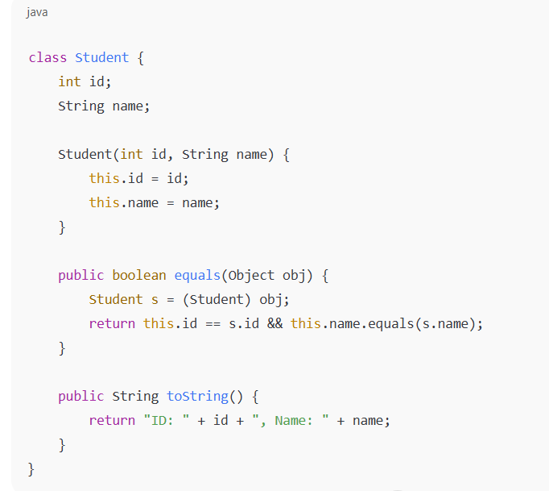

**🔷 2. java.util.Date, Calendar, and SimpleDateFormat**

**✅ java.util.Date**

Represents date and time down to milliseconds.

Date d = new Date();

System.out.println(d); // Outputs current date and time

**✅ SimpleDateFormat – For Date Formatting/Parsing**

**Converting Date to String and String to Date using SimpleDateFormat class:**

Date d = new Date();

SimpleDateFormat sdf = new SimpleDateFormat("dd/MM/yyyy");

String formatted = sdf.format(d); // Converts Date to String

Date parsed = sdf.parse("10/07/2025"); // Converts String to Date

**✅ Calendar Class (Abstract Class)**

For manipulating dates and times.

Calendar cal = Calendar.getInstance();

cal.set(Calendar.YEAR, 2025);

int year = cal.get(Calendar.YEAR);

**Q8. Which class is used to manipulate individual date fields like year, month?**  
Calendar

**🔸 Difference: Date, Calendar, LocalDate**

| **Feature** | **Date** | **Calendar** | **LocalDate (Java 8+)** |
| --- | --- | --- | --- |
| Type | Class | Abstract Class | Final Class (Immutable) |
| Thread-safe | No | No | Yes |
| Parsing | Manual via SimpleDateFormat | Yes | Yes with formatters |

new Date().toString() 🡺System default format string

Like: Thu Jul 11 10:30:05 IST 2025

# 🔶 19.1 Introduction to Collections Framework in Java

**✅ What is the Collections Framework?**

Java Collections Framework provides a set of classes and interfaces for storing and manipulating groups of data as a **single unit**. It includes interfaces like List, Set, Queue, and Map along with concrete implementations.It provides:

* Interfaces (e.g., List, Set, Map, Queue)
* Implementations (e.g., ArrayList, HashSet, HashMap)
* Algorithms (e.g., sorting, searching using Collections class)
* Utility classes (Collections, Arrays)

**✅ Why Collections?**

Before collections, Java used **arrays** which have:

* Fixed size
* No built-in methods for searching, sorting, etc.
* No flexibility (primitive vs objects)

Collections solve this:

* Dynamic size
* Rich API for data manipulation
* Support for generic types (type-safe)
* Ready-to-use data structures

**🔶 19.2 Collection Hierarchy**

Iterable

|

Collection

/ | \

List Set Queue

↓ ↓ ↓

ArrayList HashSet PriorityQueue

LinkedList TreeSet Deque

Vector LinkedHashSet

• **java.lang.Iterable:** The top-most interface. It provides the iterator() method, allowing collections to be iterated using enhanced for-loops (for-each loops).

• **java.util.Collection:** The root interface of the collection hierarchy. It defines common operations that all collections should support: add(), remove(), contains(), size(), isEmpty(), clear(), toArray(), etc. It does NOT allow direct access by index.

• **java.util.List:** (Ordered, allows duplicates, index-based access)

• **java.util.Set:** (Unordered, no duplicates)

• **java.util.Queue:** (Ordered for processing, typically FIFO - First-In, First-Out)

• **java.util.Map:** (Stores key-value pairs, **NOT** strictly part of the Collection interface hierarchy but is part of the Collections Framework).

🡺Which collection is best when frequent insertions and deletions are needed at both ends? 🡺linkedlist

**✅ List Interface**

**Definition**: A List is an ordered collection (also called a sequence). It allows:

* Duplicates
* Null values
* Insertion order is preserved
* Index-based access
* put() belongs to Map, not List.

**Common Implementations**:

| **Class** | **Underlying DS** | **Best Use Case** |
| --- | --- | --- |
| ArrayList | Dynamic Array | Fast random access (get/set), frequent reading |
| LinkedList | Doubly Linked List | Slower access time Frequent insertions/deletions at both ends |
| Vector | Synchronized ArrayList | Legacy thread-safe alternative |

**1. ArrayList**

* Grows dynamically (default size is 10)
* Resizable-array implementation
* Not synchronized
* Allows null values and duplicates

**🔸 2. LinkedList**

* Each element (node) points to the next and previous
* Good for frequent insertion/deletion
* **Slower access time** compared to ArrayList (no index-based optimization)

**🔸 3. Vector**

* Synchronized version of ArrayList
* Vector is a legacy, synchronized List class.
* Slower due to thread-safety overhead
* Legacy class, rarely used today unless thread-safety is explicitly required

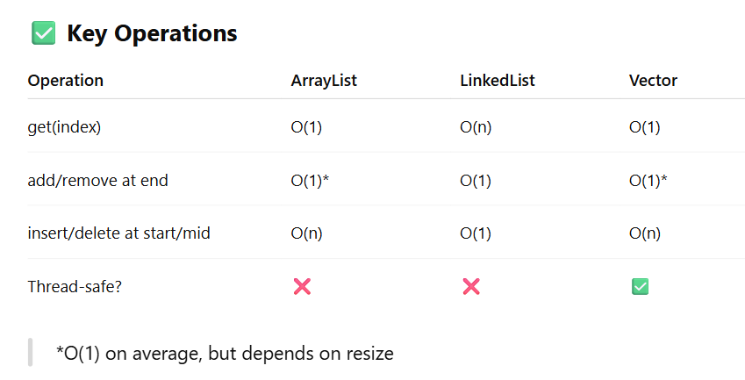

9. Which class is best suited for stack-like operations (LIFO) in modern Java?

a) Stack

b) Deque

c) LinkedList

d) ArrayList

Answer: b) Deque

Explanation: Deque is preferred over legacy Stack.

**0. Which of these is not valid for initializing a list?**

**a) List<String> list = new LinkedList<>();  
b) ArrayList list = new ArrayList();  
c) List<int> list = new ArrayList<>();  
d) List<String> list = Arrays.asList("A", "B");**

**Answer: c) List<int>  
Explanation: Java generics don't support primitive types directly.**

**13. Which is allowed in ArrayList?**

**🡺 null values  
> duplicate values**

**> heterogeneous values 🡺(You can store different types of objects)**

**Answer: d) primitive types directly You cannot use primitive types like int, char, boolean, etc. directly in an ArrayList.  
Explanation: Must use wrapper types (e.g., Integer instead of int).**

**Note 🡺** **Java Collections only store objects, not primitives.**

**17. LinkedList implements which interfaces?**

**a) List only  
b) List and Set  
c) List and Queue  
d) Set and Queue**

**Answer: c) List and Queue  
Explanation: LinkedList implements List, Deque, and Queue interfaces.**

**📌 Key Super Interfaces:**

| **Interface** | **Description** |
| --- | --- |
| Iterable | Parent of all collection types |
| Collection | Base interface for List, Set, etc. |
| List | Ordered collection with index access |
| Set | No duplicate elements |
| Queue | FIFO operations |
| Map | Not part of Collection, stores key-value pairs |

**🔶 19.3 The List Interface**

A List is an **ordered collection** that allows:

* Duplicate elements
* Index-based access
* Null values

| **Class** | **Characteristics** |
| --- | --- |
| ArrayList | Resizable array, fast random access, slower insertion |
| LinkedList | Doubly linked list, fast insert/delete, slower access |
| Vector | Legacy, synchronized version of ArrayList |

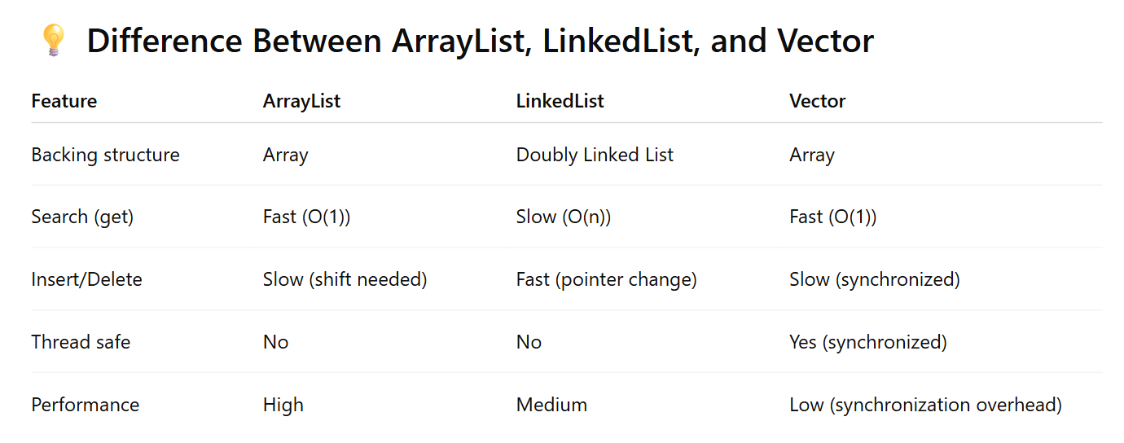

# ✅ Collections Class and Collection interface

**🔷 What is Collections?**

The Collections class is a **utility class** in java.util that provides **static methods** to operate on or return collections (like List, Set, Map). It should not be confused with the Collection interface.

**Key Use:** Perform operations such as sorting, searching, reversing, shuffling, synchronizing collections, etc.

**🔷 Common Methods of Collections class**

| **Method** | **Description** |
| --- | --- |
| sort(List) | Sorts the list in natural order (ascending) |
| reverse(List) | Reverses the order of elements |
| shuffle(List) | Randomizes the order |
| max(Collection) / min(Collection) | Returns the largest/smallest element |
| binarySearch(List, key) | Searches for key using binary search (list must be sorted) |
| fill(List, value) | Replaces all elements with specified value |
| copy(dest, src) | Copies elements from one list to another |
| replaceAll(List, oldVal, newVal) | Replaces all occurrences of oldVal with newVal |
| synchronizedList(List) | Returns thread-safe version of list |

**6. What will happen if Collections.copy(dest, src) is used and dest is smaller than src?**

**a) It will expand dest  
b) It will throw IndexOutOfBoundsException  
c) It will fill as many as possible  
d) It will compile but fail silently**

**Answer: b) It will throw IndexOutOfBoundsException  
Explanation: dest must be at least same size as src.**

**9. How do you sort a list in descending order using Collections?**

**a) Collections.sort(list, Comparator.reverseOrder())  
b) Collections.sort(list).reverse()  
c) list.sort(Collections.reverse())  
d) Collections.descSort(list)**

**Answer: a) Collections.sort(list, Comparator.reverseOrder())**

# ✅ Comparable vs Comparator in Java

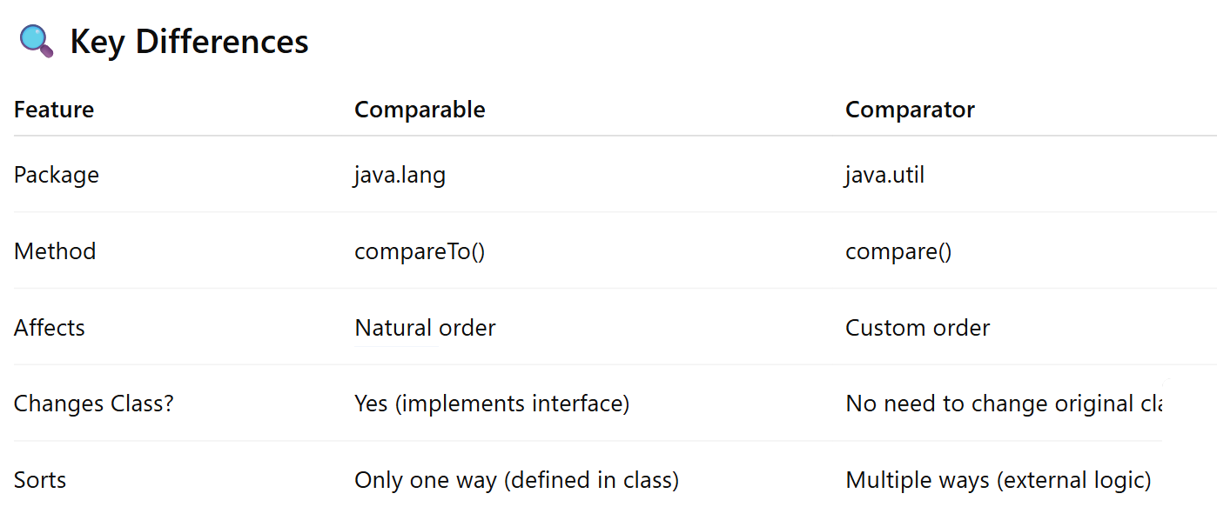

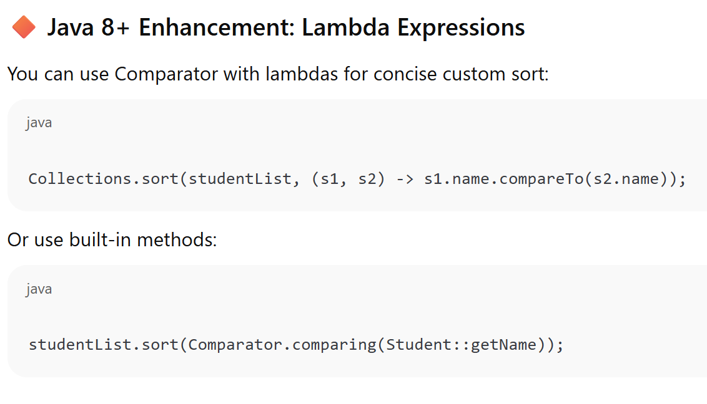

**3.** What is the key benefit of using Comparator?

a) Only one sorting logic is supported  
b) It’s always faster  
c) Multiple sorting logic can be defined without modifying the class  
d) Uses reflection

**Answer:** c) Multiple sorting logic can be defined without modifying the class  
**Explanation:** You can define various comparators as needed.

**4.** If a class implements both Comparable and is also sorted using Comparator, which takes precedence?

a) Comparable  
b) Comparator  
c) Both run  
d) Compilation error

**Answer:** b) Comparator  
**Explanation:** If a Comparator is passed to sort(), it overrides natural order.

**6.** Can we sort objects in descending order using Comparable?

a) No, Comparable only sorts ascending  
b) Yes, by reversing the logic inside compareTo()  
c) Yes, by using Comparator.reverseOrder()  
d) b and c both

**Answer:** d) b and c both  
**Explanation:** You can reverse logic in compareTo() or use Comparator to reverse order.

# ✅ Java Queue Collection

**🔷 1. What is a Queue?**

A **Queue** in Java is a **linear data structure** that follows the **First In, First Out (FIFO)** principle. The element added first is removed first.

**🔑 Key Interfaces:**

* Queue<E> (in java.util)
* Deque<E> (Double-ended Queue)
* BlockingQueue<E> (for concurrent use)

**🔷 2. Common Implementations of Queue**

| **Implementation** | **Description** |
| --- | --- |
| LinkedList | Basic Queue implementation (non-thread safe). Also implements List. |
| PriorityQueue | Elements ordered by natural order or Comparator. Not thread-safe. |
| ArrayDeque | Resizable array-based Deque. Faster than Stack/LinkedList for some uses. ArrayDeque is a double-ended queue (Deque). |
| ConcurrentLinkedQueue | High-performance thread-safe queue. |
| BlockingQueue (like ArrayBlockingQueue, LinkedBlockingQueue) | Thread-safe queues for producer-consumer problems |

**🔷 3. Important Methods in Queue Interface**

| **Method** | **Description** |
| --- | --- |
| add(E e) | Inserts element. Throws exception if full. |
| offer(E e) | Inserts element. Returns false if full. |
| remove() | Retrieves and removes head. Exception if empty. |
| poll() | Retrieves and removes head. Returns null if empty. |
| element() | Retrieves head without removing. Exception if empty. |
| peek() | Retrieves head without removing. Returns null if empty. |

**🔷 5. PriorityQueue in Java**

A PriorityQueue **does not follow FIFO**. It arranges elements in natural order (for primitive wrappers or Comparable types) or via custom Comparator.

**Which interface does PriorityQueue implement? 🡺queue**

# ✅ Java Set Collection (Sessions 23 & 24)

**🔷 1. What is a Set?**

A **Set** is a collection that **does not allow duplicate elements**. It models the mathematical set abstraction and is part of the java.util package.

**🔑 Key Properties:**

* No duplicates.
* Order is not guaranteed (except for some implementations).
* Uses equals() and hashCode() methods to identify duplicates.

**🔷 2. Types of Set Implementations**

| **Set Type** | **Preserves Order** | **Allows Null** | **Backed By** | **Sorted?** |
| --- | --- | --- | --- | --- |
| **HashSet** | ❌ No | ✅ One null | Hash table | ❌ No |
| **LinkedHashSet** | ✅ Yes (insertion) | ✅ One null | Hash table | ❌ No |
| **TreeSet** | ✅ Yes (sorted) | ❌ (Null not allowed if sorted) | Red-Black Tree | ✅ Yes (natural or custom) |

**🔷 6. Backed Collections**

Java allows **backed collections**, where a Set view is connected to the underlying Map. A change in one reflects in the other.

Example:

Map<String, Integer> map = new HashMap<>();

Set<String> keySet = map.keySet();

Any change to map will affect keySet, and vice versa.

**🔷 7. Null Handling in Set**

* HashSet and LinkedHashSet allow **one null** element.
* TreeSet throws NullPointerException if you try to add null (when using Comparable/Comparator).

**🔷 8. Performance Overview**

| **Operation** | **HashSet** | **LinkedHashSet** | **TreeSet** |
| --- | --- | --- | --- |
| Insertion | O(1) | O(1) | O(log n) |
| Lookup | O(1) | O(1) | O(log n) |
| Maintains Order | ❌ No | ✅ Yes | ✅ Sorted |

**🔷 1. Introduction to Map in Java**

The Map interface in Java represents a collection of **key-value pairs**, where:

* Each key is unique.
* A key maps to **at most one value**.
* It does **not extend Collection**, but it's part of the Java Collections Framework.

### **Q7. Which method gives a view of all entries in a Map?**

a) keySet()  
b) values()  
c) entrySet()  
d) mapSet()

**Answer:** c) entrySet()  
👉 **Explanation:** entrySet() gives a Set of key-value pairs (Map.Entry<K,V>).

**🔑 Common Implementations:**

| **Class** | **Ordered?** | **Sorted?** | **Thread-Safe?** | **Allows nulls?** |
| --- | --- | --- | --- | --- |
| HashMap | ❌ No | ❌ No | ❌ No | ✅ One null key, many null values |
| LinkedHashMap | ✅ Insertion | ❌ No | ❌ No | ✅ Same as HashMap |
| TreeMap | ✅ Sorted (by key) | ✅ Yes | ❌ No | ❌ Null keys not allowed |
| Hashtable | ❌ No | ❌ No | ✅ Yes | ❌ Null keys/values not allowed |

**🔹 2. HashMap**

**✅ Features:**

* Based on **hashing**.
* Allows **one null key** and multiple null values.
* Not synchronized.
* No ordering of keys.

**🔍 Internal Working:**

* Uses an array of buckets.
* Uses hashCode() and equals() to find the correct bucket.
* If keys have the same hash, uses **chaining (LinkedList or Tree after Java 8)**.

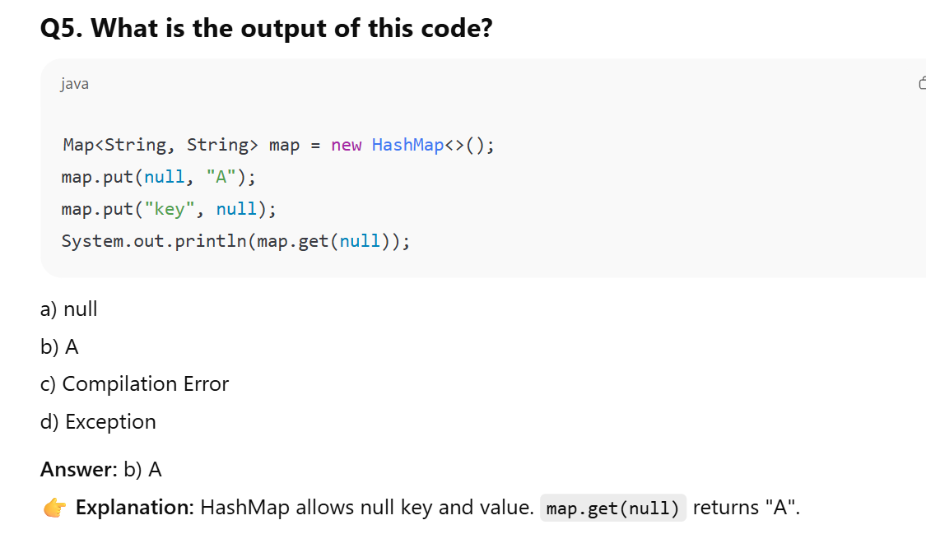

**🔹 3. LinkedHashMap**

**✅ Features:**

* Maintains **insertion order**.
* Slightly slower than HashMap.
* Good for **LRU Caching**, etc.

Map<String, Integer> map = new LinkedHashMap<>();

**🔹 4. TreeMap**

**✅ Features:**

* Implements **SortedMap**.
* Sorted based on **natural order** or a custom comparator.
* **Null keys not allowed** (throws NullPointerException).
* TreeMap uses compareTo() for sorting; null keys cannot be compared.
* Backed by **Red-Black Tree**.

TreeMap<String, Integer> map = new TreeMap<>();

**🔹 5. Hashtable**

**✅ Features:**

* Thread-safe (all methods are synchronized).
* Legacy class (use ConcurrentHashMap for modern needs).
* Does **not allow null keys or values**.

Hashtable<String, String> table = new Hashtable<>();

**🔹 6. Backed Map Collections**

Backed collections are **views** of the original Map:

* keySet(), values(), entrySet() return backed views.
* Modifying the view **modifies the original Map**, and vice versa.

Map<String, Integer> map = new HashMap<>();

Set<String> keys = map.keySet(); // backed view

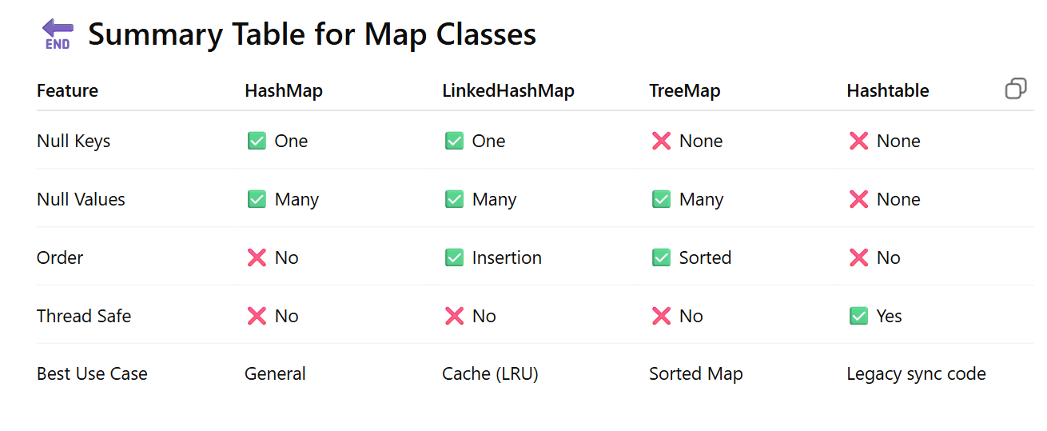

**6. You want a thread-safe, sorted Map that does not allow null keys or values. Which should you use?**

a) TreeMap  
b) ConcurrentHashMap  
c) Collections.synchronizedMap(new TreeMap<>())  
d) ConcurrentSkipListMap

**Answer:** d) ConcurrentSkipListMap

**Explanation:**  
ConcurrentSkipListMap is a **sorted, thread-safe Map**, and like TreeMap, does **not allow null keys or null values**.

**Q8. Which of these classes does NOT allow null keys or null values?**

a) HashMap  
b) TreeMap  
c) Hashtable  
d) LinkedHashMap

**Correct Answer:** **c) Hashtable**

✅ **Explanation:**

* Hashtable does **not allow null keys or null values**.
* TreeMap does **not allow null keys** (with default comparator), but **does allow null values**.
* HashMap and LinkedHashMap allow **one null key** and **many null values**

**✅ Concurrent Collections in Java (Sessions 25 & 26)**

Concurrent Collections are specially designed classes in the java.util.concurrent package to safely handle multithreaded environments **without explicit synchronization**. Traditional collections like ArrayList, HashMap, or HashSet are **not thread-safe**.

**🔹 Why Use Concurrent Collections?**

* In a multithreaded environment, if multiple threads access and modify collections simultaneously, it can cause **data inconsistency, corruption, or ConcurrentModificationException**.
* Concurrent collections handle internal synchronization efficiently to avoid these problems.

**🔹 Key Concurrent Collection Classes**

| **Collection Type** | **Traditional Version** | **Concurrent Version** |
| --- | --- | --- |
| List | ArrayList | CopyOnWriteArrayList |
| Map | HashMap | ConcurrentHashMap |
| Set | HashSet | ConcurrentSkipListSet / CopyOnWriteArraySet |
| Queue | LinkedList | ConcurrentLinkedQueue / BlockingQueue |
| Sorted Map | TreeMap | ConcurrentSkipListMap |

**🔸 1. ConcurrentHashMap**

* Thread-safe version of HashMap
* Allows **concurrent read and updates without locking the entire map**
* Uses **segment-based locking (Java 7)** or **bucket-level CAS + synchronized blocks (Java 8+)**
* **Does not allow null keys or null values**

java

CopyEdit

ConcurrentHashMap<String, Integer> map = new ConcurrentHashMap<>();

map.put("Java", 1);

map.put("Python", 2);

**🔸 2. CopyOnWriteArrayList**

* Used when **reads are more frequent than writes**
* Every modification (add, remove) creates a new copy of the underlying array
* Thread-safe without external synchronization

java

CopyEdit

CopyOnWriteArrayList<String> list = new CopyOnWriteArrayList<>();

list.add("Java");

list.add("Python");

**🔸 3. ConcurrentLinkedQueue**

* A **non-blocking, thread-safe** queue based on **linked nodes**
* Uses **CAS (Compare-And-Swap)** for atomic updates
* Follows FIFO order
* Suitable for **high-concurrency** environments

ConcurrentLinkedQueue<String> queue = new ConcurrentLinkedQueue<>();

queue.add("A");

queue.poll(); // removes the head

**🔸 4. BlockingQueue (Interface)**

Supports operations that wait:

* put(E e) – Waits if necessary for space
* take() – Waits if necessary for an element

**Implementations:**

* ArrayBlockingQueue – Bounded
* LinkedBlockingQueue – Optional bound
* PriorityBlockingQueue – Priority-based
* DelayQueue, SynchronousQueue, LinkedTransferQueue

**🔸 5. ConcurrentSkipListMap and ConcurrentSkipListSet**

* Sorted, thread-safe versions of TreeMap and TreeSet
* Based on **Skip List** (not trees)
* **Null keys/values not allowed**

**🔸 6. Comparison with Synchronized Collections**

| **Feature** | **Synchronized Collections** | **Concurrent Collections** |
| --- | --- | --- |
| Provided by | Collections.synchronizedXXX() | java.util.concurrent package |
| Locking | Whole object | Fine-grained/lock-free |
| Performance in concurrency | Poor | High |
| Fail-fast behavior | Throws ConcurrentModificationException | Fail-safe |

**2. Which collection is suitable for use in a producer-consumer pattern where the producer must block if the queue is full?**

a) ConcurrentLinkedQueue  
b) ArrayList  
c) ArrayBlockingQueue  
d) LinkedList

**Answer:** c) ArrayBlockingQueue  
**Explanation:** ArrayBlockingQueue blocks producers when full and consumers when empty.

**5. What is the key mechanism used in ConcurrentLinkedQueue for thread-safe operations?**

a) Locks  
b) Semaphores  
c) Compare-And-Swap (CAS)  
d) Blocking

**Answer:** c) Compare-And-Swap (CAS)  
**Explanation:** CAS is a lock-free mechanism used for atomic updates in ConcurrentLinkedQueue.

# ✅ Java 8 Stream API

**🔹 What is a Stream in Java?**

* A **Stream** is a sequence of elements supporting **sequential** and **parallel** operations.
* It is **not a data structure**. It does **not store elements**—instead, it **carries values from a source** (like a Collection or array), through a **pipeline** of operations.

**🔸 Stream API Goals**

* **Declarative**: What to do, not how to do it.
* **Efficient**: Laziness and short-circuiting improve performance.
* **Functional style**: Allows chaining operations using lambdas.
* **Parallel-friendly**: Built-in support for parallel data processing. I,e Streams doesn’t support only sequential operations

**🔹 Stream Pipeline Components**

Collection<Integer> numbers = Arrays.asList(1, 2, 3, 4, 5);

✅ Filtering Even Numbers

int sum = numbers.stream() // 1. Source

.filter(n -> n % 2 == 0) // 2. Intermediate Operation

.map(n -> n * n)

.reduce(0, Integer::sum); // 3. Terminal Operation

* **Source**: Where data comes from (like List, Set, Map, arrays)
* **Intermediate operations**: Transform data (like map, filter) 🡺 Intermediate operations like map, filter are not executed until a terminal operation is called.
* **Terminal operations**: Produce a result or side-effect (forEach, collect, reduce)

**🔸 Stream Operations**

**🔹 Intermediate Operations (return Stream)**

| **Method** | **Description** |
| --- | --- |
| filter(Predicate) | Filters elements based on condition |
| map(Function) | Transforms each element |
| flatMap(Function) | Flattens nested streams |
| sorted() | Sorts stream elements |
| distinct() | Removes duplicates |
| limit(n) / skip(n) | Truncates or skips elements |

**🔹 Terminal Operations (return result)**

| **Method** | **Description** |
| --- | --- |
| forEach(Consumer) | Performs action for each element |
| collect(Collector) | Reduces elements to a collection |
| reduce() | Aggregates into a single value |
| count() | Counts elements |
| anyMatch()/allMatch()/noneMatch() | Predicate checks |

**4. Which Stream method is used to convert a Stream of objects into a collection like List or Set?**

a) reduce()  
b) collect()  
c) map()  
d) forEach()

**Answer:** b) collect()  
**Explanation:** collect() is used with Collectors.toList(), toSet(), etc.

🡺 flatMap() is used for flattening nested structures like List of Lists.

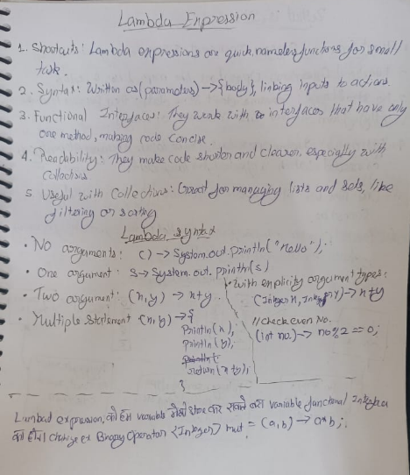

Choose the incorrect syntax for a lambda expression.

Revisit

Choose the best option

O (param) -> System.out.println("parameterized lambda expression");

O () -> System.out.println("lambda expression");

O (String s) -> ("lambda expression of type String");

O () -> 3.567

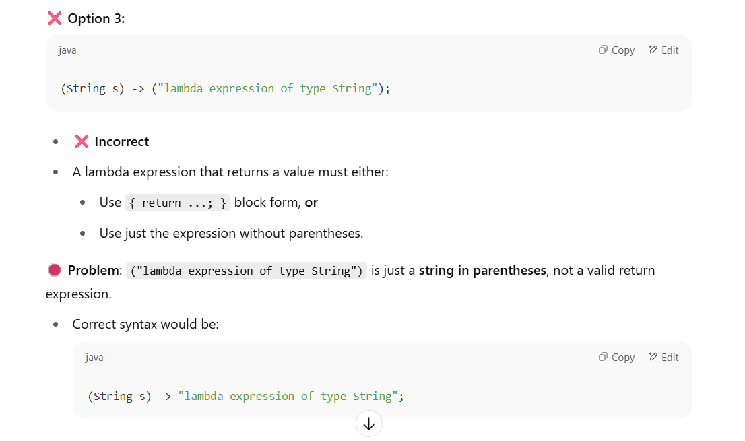

# 🧵 Multithreading in Java (Session 27)

**✅ What is Multithreading?**

Multithreading is a Java feature that allows **concurrent execution of two or more parts** of a program for maximum CPU utilization.

* Each **thread** runs **independently**.
* Threads share the **same memory space**.
* Helps in performing **background tasks** while the main task continues.

**🔹 Key Classes and Interfaces**

| **Component** | **Description** |
| --- | --- |
| Thread class | Used to create a thread by extending it |
| Runnable interface | Used when creating thread via composition |

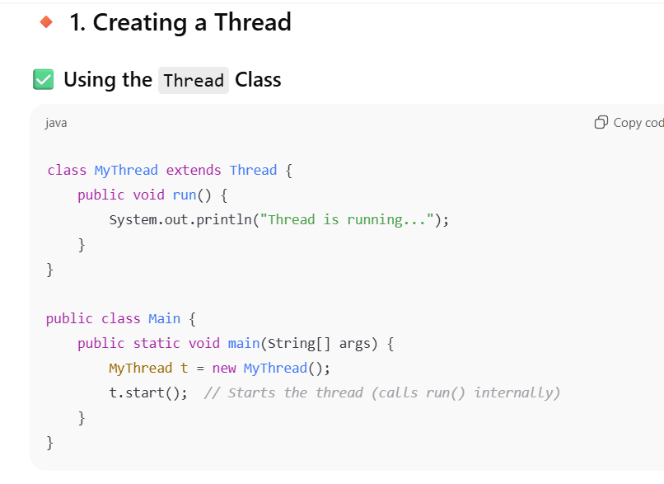

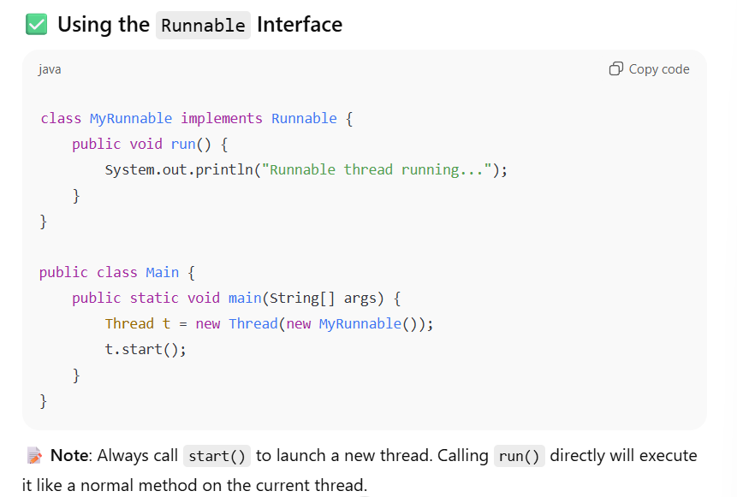

**🔸 2. Common Thread Methods**

| **Method** | **Description** |
| --- | --- |
| **start()** | **Starts the thread (calls run() internally)** |
| **run()** | **Code inside this runs in a new thread** |
| **sleep(ms)** | **Pauses the thread for given milliseconds** |
| **join()** | **Waits for a thread to finish execution** |
| **yield()** | **Suggests to the scheduler to switch context to another runnable thread** |
| **setPriority(int)** | **Sets thread priority (1–10 range)** |
| **getPriority()** | **Gets current thread priority** |

**✅ Thread.sleep()**

* **The sleep() method pauses the currently executing thread for a specified amount of time in milliseconds (optionally nanoseconds).**
* **It does not release any locks held by the thread.**
* **The thread resumes automatically after the sleep time is over.**

### 🧠 Note:

* sleep() is a **static method** of the Thread class.
* It throws InterruptedException, so you need to **handle or declare** it.

**a) wait()**

* **Defined in Object class, not in Thread.**
* **Used for inter-thread communication (e.g., with notify()).**
* **Must be called within a synchronized block or method.**
* **It releases the lock held by the thread.**
* Used in advanced concurrency scenarios like Producer–Consumer problems.

**yield()**

* **Also a static method of Thread.**
* **Hints to the thread scheduler that the current thread is willing to yield its CPU to another thread of the same or higher priority.**
* **Does not pause for a fixed time and doesn’t guarantee anything.**
* **Rarely used in modern Java due to unpredictable behavior.**

**2. What happens if you call run() instead of start() on a thread?**

**a) Thread runs in the background  
b) A new thread is created  
c) Code runs in the current thread, not a new one  
d) Compile-time error**

**Answer: c) Code runs in the current thread, not a new one  
Explanation: run() behaves like a normal method call.**

**start() creates a new call stack for the thread, while run() would simply execute the code in the current thread**

**🔸 3. Thread Lifecycle**

1. **New – Thread object is created**
2. **Runnable – After start() is called**
3. **Running – Selected by CPU and currently executing**
4. **Blocked/Waiting – Waiting for a resource or signal**
5. **Terminated – Execution completed or stopped**

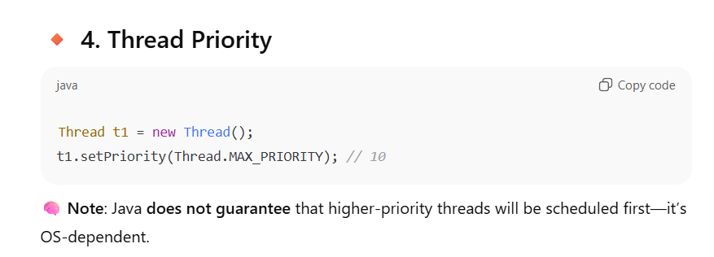

From Thread.MIN_PRIORITY (1) to Thread.MAX_PRIORITY (10), with Thread.NORM_PRIORITY (5) as default.

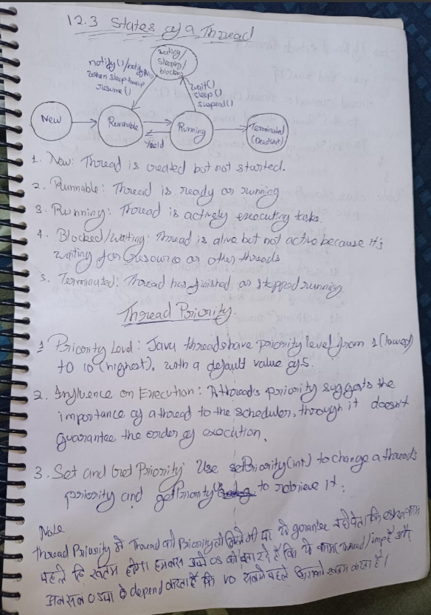

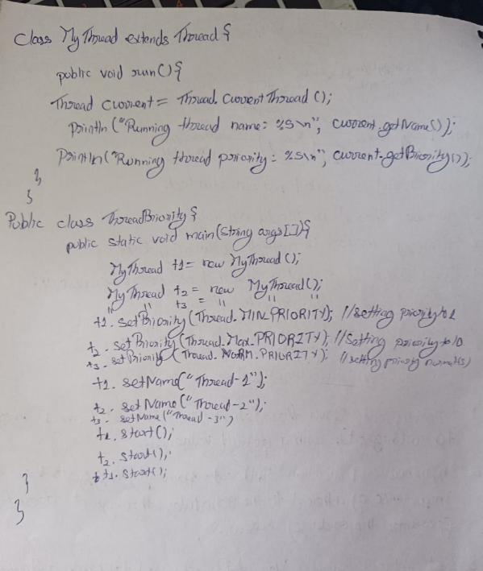

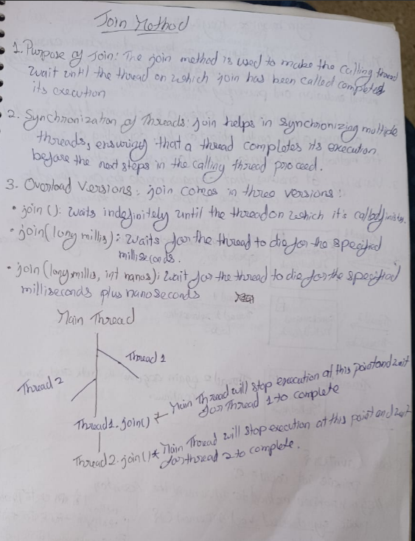

* **Daemon threads** are low-priority threads that run in the background, primarily for performing services to user threads.
* The JVM terminates when all **non-daemon** threads have finished their execution. When the last non-daemon thread terminates, the JVM exits, and all remaining daemon threads are abruptly terminated.

**Best option: Once all non-daemon threads execution is comple**

# 🔒 Session 28: Synchronization, Deadlock, wait(), notify(), Producer–Consumer

**🔹 1. What is Synchronization in Java?**

Java is **multithreaded**, so **multiple threads can access shared resources concurrently**. This can lead to **race conditions** or **data inconsistency**.

**✅ Synchronization ensures:**

Only **one thread can access a shared resource** at a time — like placing a lock on an object.

**🔧 Syntax for synchronized block:**

synchronized(object) {

// Critical section

}

**🔧 Synchronized method:**

public synchronized void increment() {

count++;

}

Behind the scenes, every object in Java has an **intrinsic lock** or **monitor**.

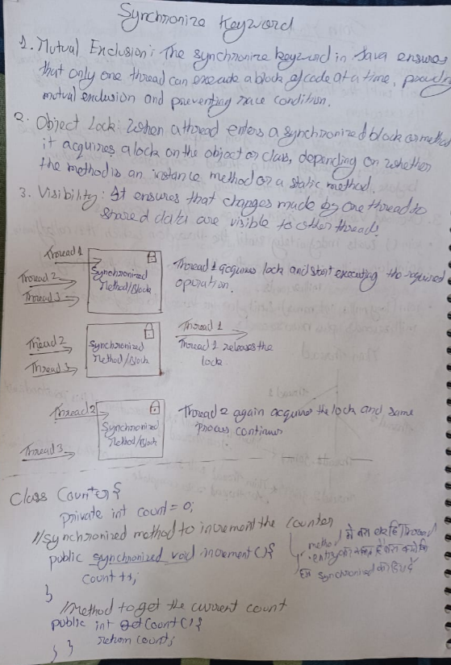

**🔹 3. wait(), notify(), and notifyAll()**

These are methods in the Object class (not Thread!), and they work **only inside synchronized blocks or methods**.

**✅ wait():**

Makes the thread **release the lock and go to WAITING state**.

**✅ notify():**

**Wakes up one waiting thread**, allowing it to re-acquire the lock.

**✅ notifyAll():**

**Wakes up all threads** waiting on that object’s monitor.

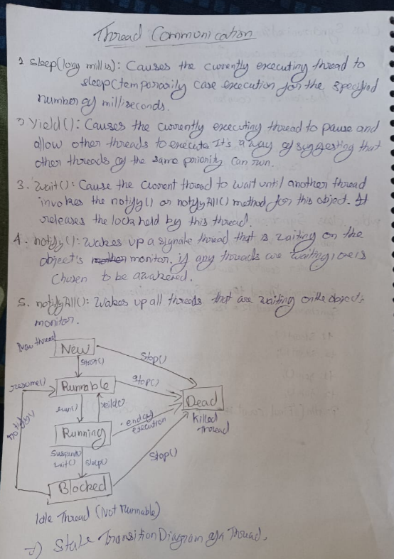

**🔧 Example:**

synchronized(lock) {

lock.wait(); // thread releases lock and waits

lock.notify(); // notifies one thread

lock.notifyAll(); // notifies all waiting threads

}

Threads that call wait() will not resume until another thread calls notify() or notifyAll() on the same object.

**🔥 Important: Difference between sleep() and wait()**

| **Feature** | **sleep()** | **wait()** |
| --- | --- | --- |
| Belongs to | Thread class | Object class |
| Releases lock? | ❌ No | ✅ Yes |
| Needs sync? | ❌ No | ✅ Yes |
| Usage | Pause execution | Thread communication |

**🔥 Deadlock in Java**

Occurs when **two or more threads are blocked forever**, each waiting for a lock held by the other.

**🔧 Deadlock example:**

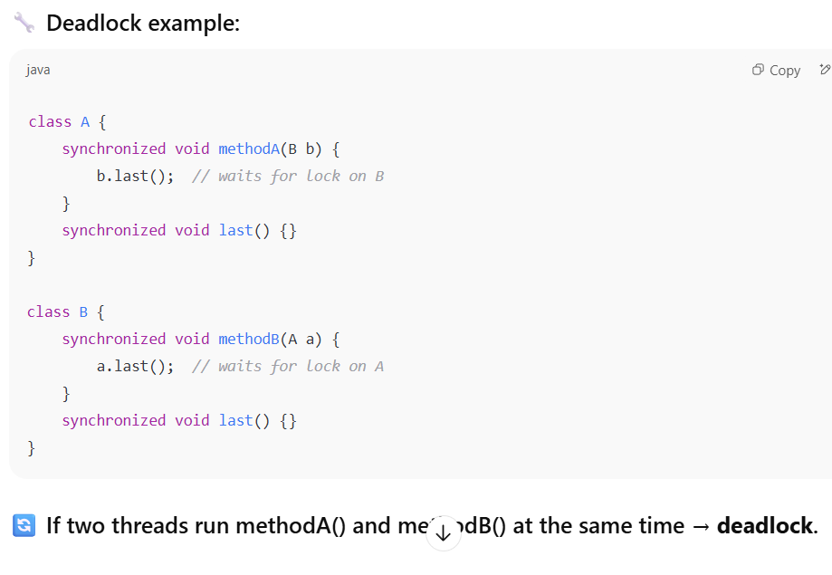

**🛠️ Producer–Consumer Problem (Classic wait-notify example)**

* **Producer** thread produces items and **puts** into a shared queue.
* **Consumer** thread takes from the queue.
* wait() is used when the buffer is **empty/full**, and notify() is used to **wake up** other threads.

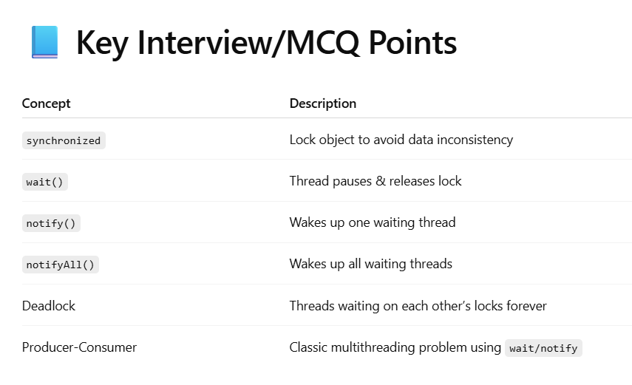

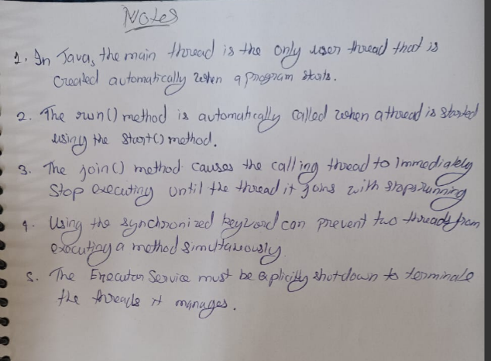

**Q1. Which statement is true about synchronized keyword?**

a) It can only be used with static methods  
b) It prevents all threads from accessing the method  
**c) It prevents multiple threads from executing the method on the same object**d) It stops thread execution completely

**Q2. What happens if a thread calls wait() without holding the lock?**

a) It waits successfully  
b) It throws InterruptedException  
**c) It throws IllegalMonitorStateException**  
d) It blocks forever

**Q3. Which method releases the monitor lock when executed?**

a) sleep()  
**b) wait()**  
c) notify()  
d) yield()

**Q4. How can you avoid deadlock?**

a) Use Thread.sleep()  
b) Use multiple locks simultaneously  
**c) Always lock resources in the same order**  
d) Call System.gc()

# 🧠 Part A: Generics in Java

**✅ Why Use Generics?**

* Provides **compile-time type safety**.
* Eliminates the need for **typecasting**.
* Makes code **cleaner and reusable**.

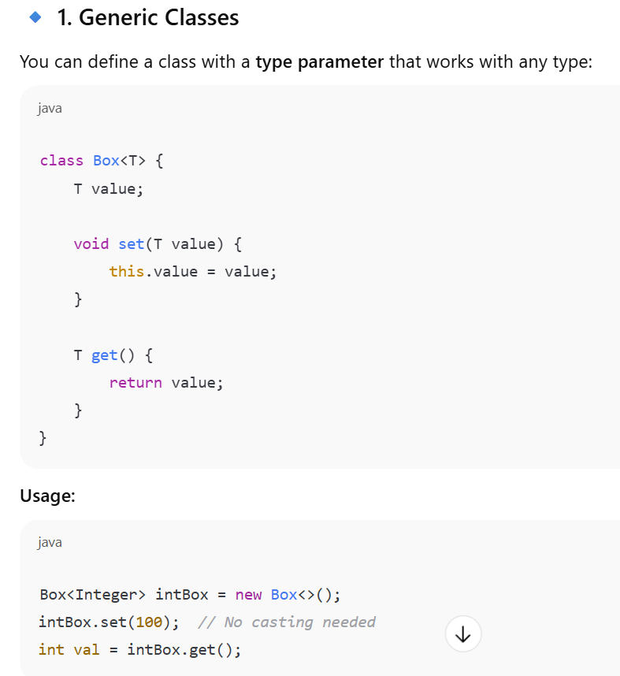

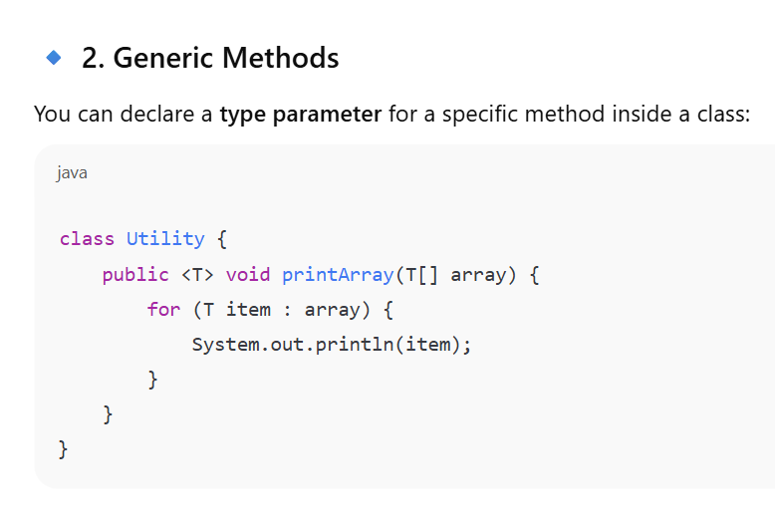

**🔹 3. Bounded Type Parameters**

You can restrict the types using extends:

class Calculator<T extends Number> {

T value;

}

* Here T can only be a subclass of Number (like Integer, Double).

### 🔹 5. Raw Types (Discouraged)

Using generics without specifying type is called **raw type** and causes **type-safety loss**.

Box rawBox = new Box(); // BAD PRACTICE

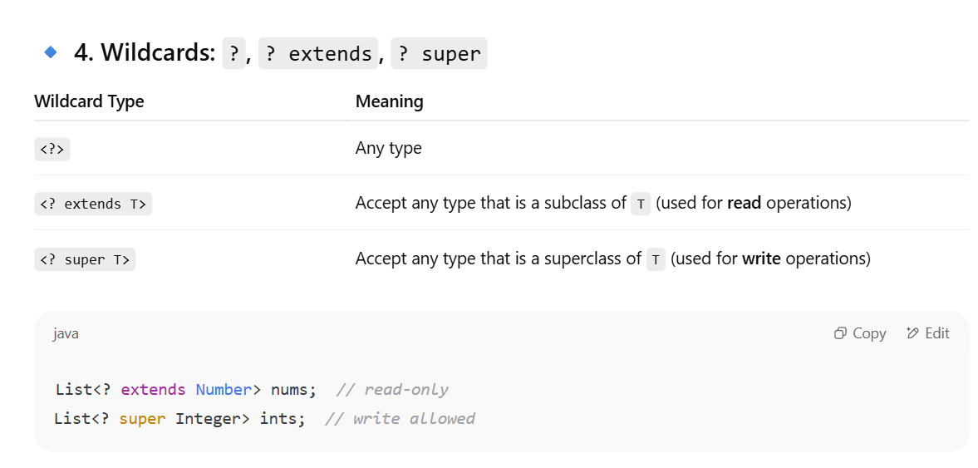

**Metadata & Reflection API**

* **Metadata:** Data that describes other data. In Java, metadata about classes, methods, fields, and constructors is stored within the .class files.
* **Reflection API (java.lang.reflect package):**
  + **Purpose:** Allows a Java program to inspect and modify its own structure (classes, methods, fields) at **runtime**.
  + **It is used to access private method using its class object**: True. Using Method.setAccessible(true), you can invoke private methods or access private fields.
  + **Capabilities:**
    1. **Inspect:** Determine the class of an object, get its superclass, interfaces, fields, methods, constructors, and annotations.
    2. **Instantiate:** Create new instances of classes.
    3. **Invoke:** Call methods and access/modify fields, even private ones.
  + **Core Classes:**
    1. Class: Represents classes and interfaces. You get a Class object using object.getClass(), ClassName.class, or Class.forName("ClassName").
    2. Method: Represents a single method declared by a class or interface.
    3. Field: Represents a field (member variable) of a class or interface.
    4. Constructor: Represents a constructor of a class.
  + **Use Cases:**
    1. **Frameworks/Libraries:** Used extensively by frameworks (e.g., Spring, Hibernate, JUnit) for dependency injection, ORM mapping, unit testing, etc.
    2. **Dynamic Proxies:** Creating proxy objects at runtime.
    3. **Debugging Tools:** IDEs and debuggers use reflection.
    4. **Serialization/Deserialization:** Some libraries use reflection to inspect and recreate objects.
  + **Drawbacks:**
    1. **Performance Overhead:** Reflection operations are slower than direct calls.
    2. **Security Concerns:** Can bypass access restrictions (e.g., setAccessible(true) for private members).
    3. **Breaks Type Safety:** Runtime errors instead of compile-time.
    4. **Complexity:** Can make code harder to read and maintain.

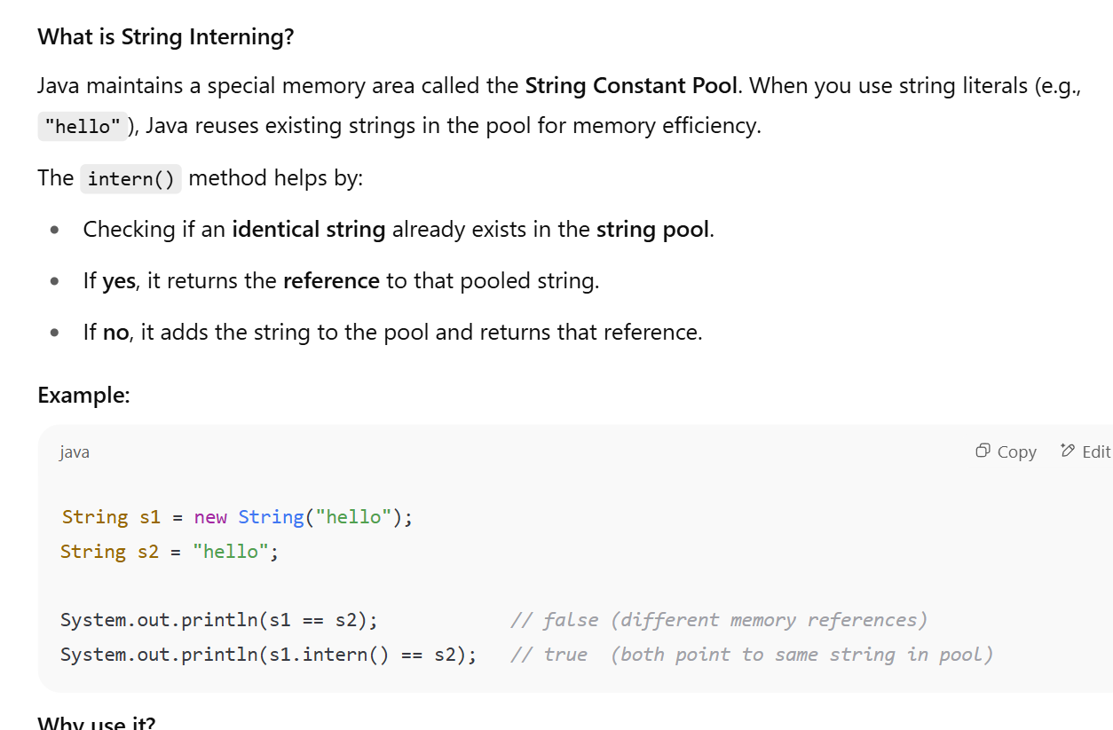

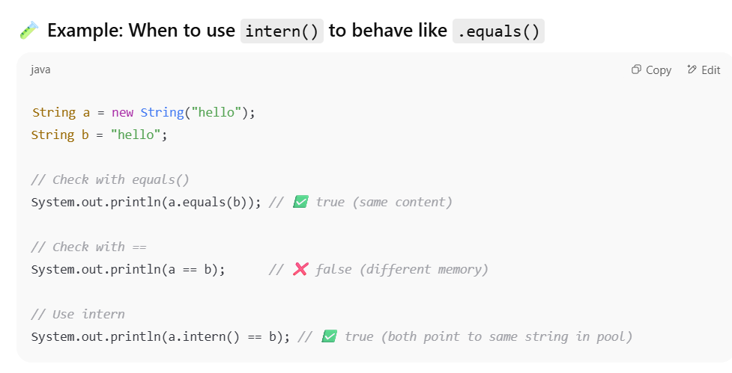

🡺Object value = 13.401🡺Auto Boxing and Up Casting